**ВИСОКА ШКОЛА СТРУКОВНИХ СТУДИЈА ЗА ВАСПИТАЧЕ И**

**ПОСЛОВНЕ ИНФОРМАТИЧАРЕ СИРМИЈУМ**

**E-COMERCIAL SEMINARSKI RAD**

**Profesori: Студент:**

**Zdravko Ivanković, Valentina Džambić 32/2020 - i**

**Saša Sudar.**

**UVOD**..................................................................................................................................................3

## 1. HTML

1.1 Šta je HTML.......................................................................................................................8

1.2 Za šta se koristi HTML.................................................................................................... ..8

1.3 HTML osnovne sintakse.....................................................................................................8

## 2. CSS

2.1 Šta je CSS............................................................................................................................9

1.2 Za šta se koristi CSS..........................................................................................................9

2.2 CSS osnovne sintakse.........................................................................................................9

**3. BOOTSTRAP**

3.1 Šta je BOOTSTRAP.............................................................................................................10

3.2 BOOTSTRAP osnovne sintakse...........................................................................................10

## 4. JAVASCRIPT

4.1 Šta je Javascript.................................................................................................................11

1.2 Za šta se koristi JAVASCRIPT............................................................................................11

4.2 JS osnovne sintakse...........................................................................................................11

## 5. KAKO INSTALIRATI I KORISTITI VISUAL STUDIO CODE..............................12

## 6. PISANJE NAŠEG KODA

6.1 Postavljanje BOOTSTRAP CDN-a...........................................................................................14

6.2 FOOTER.................................................................................................................................16

6.3 Dodavanje CSS-a...................................................................................................................18

6.4 Ubacivanje slika preko CSS-a................................................................................................21

6.5 Ubacivanje sličica.................................................................................................................26

6.6 TRENDING............................................................................................................................30

6.7 Welcome to our health food................................................................................................12

6.8 STORE...................................................................................................................................12

6.9 Welcome to our health food................................................................................................12

6.10 CONTACT US.......................................................................................................................12

6.11 FOOTER...............................................................................................................................12

## 8. FINALNI IZGLED NAŠEG KODA..............................................................................102

**UVOD**

Na ovom seminarskom radćemo primer E-COMMERCIALA u kom ćemo koristiti HTML5, CSS3, BOOTSTRAP5 i vrlo malo JAVASCRIPT-e. Ovaj projekat sadrži više sekcija, realizovanih kroz BOOTSTRAP.

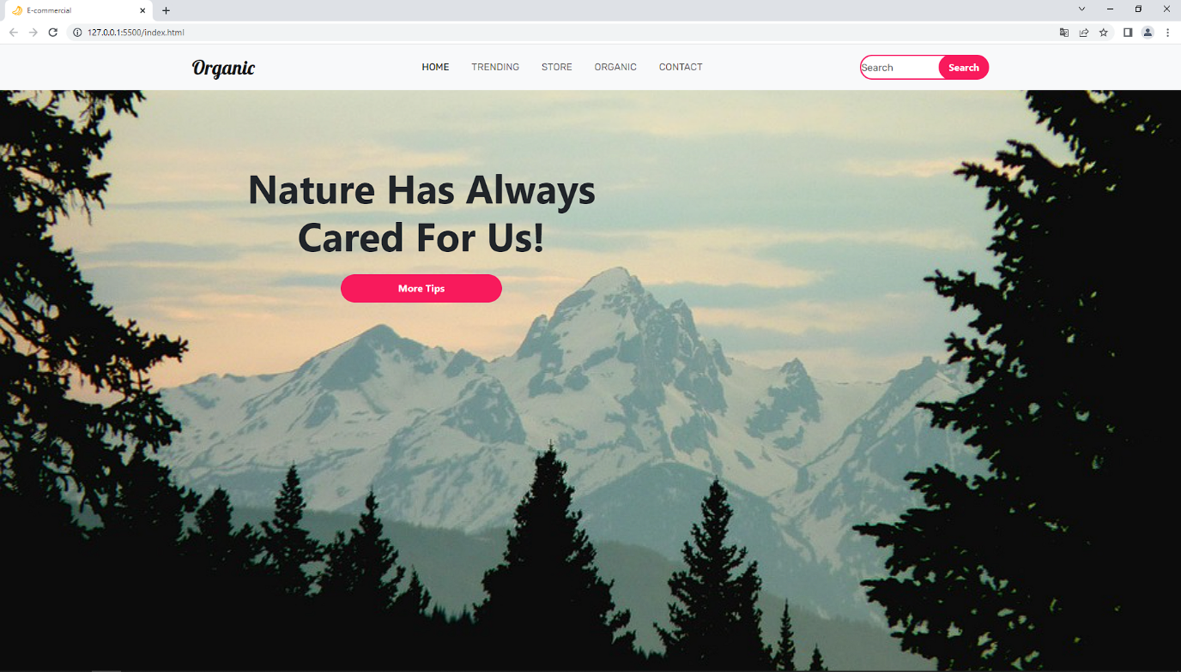

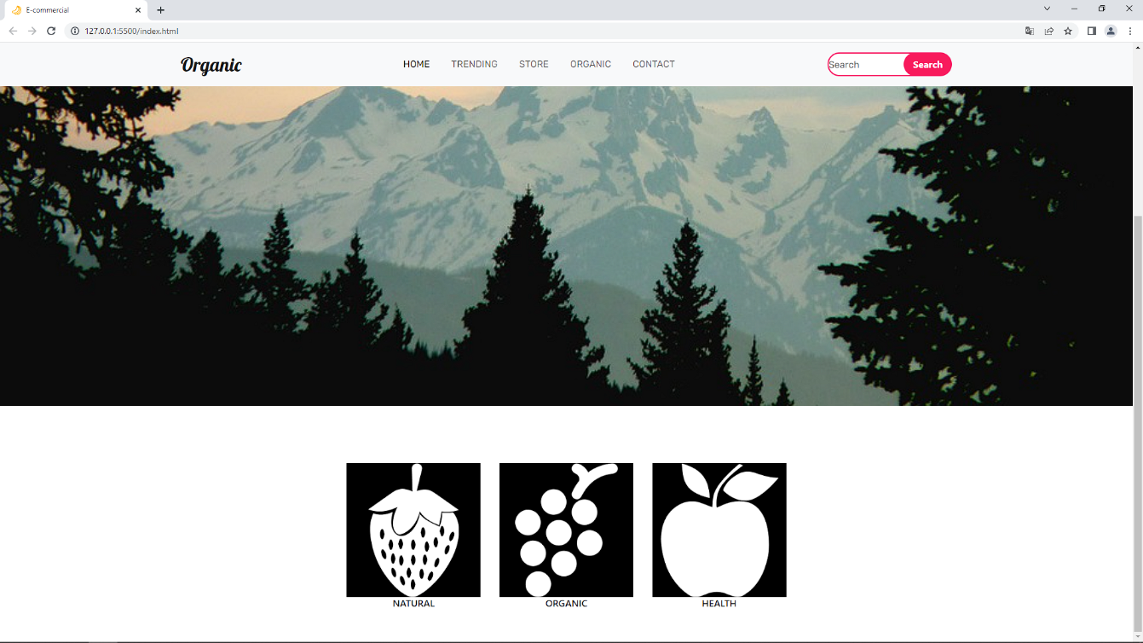

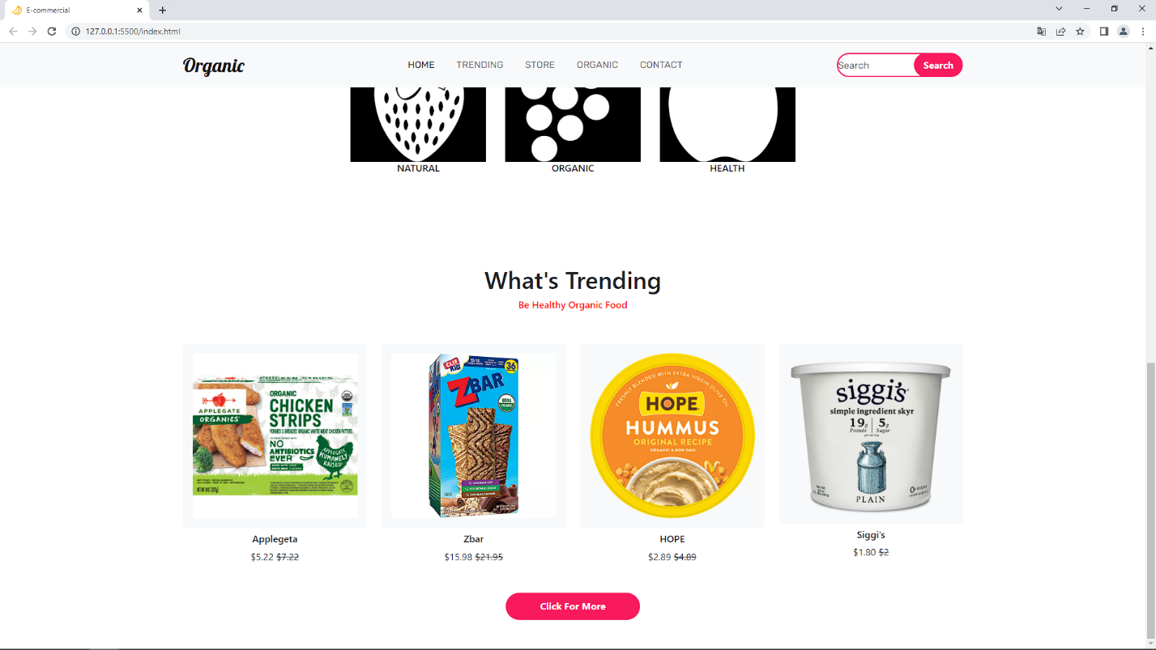

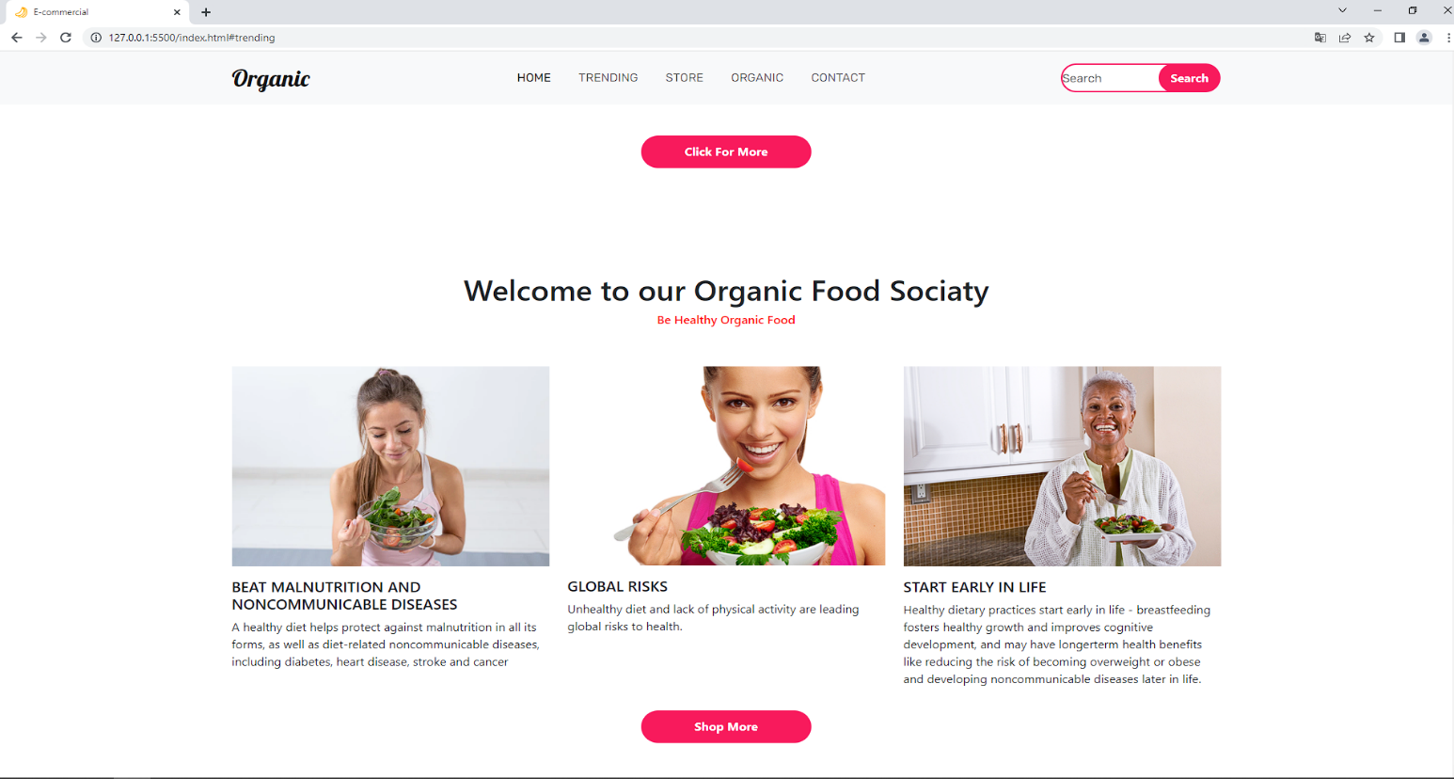

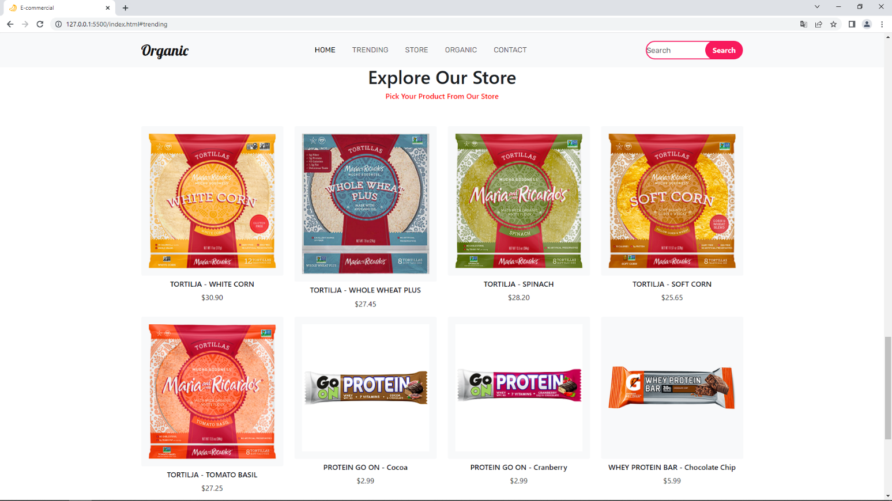

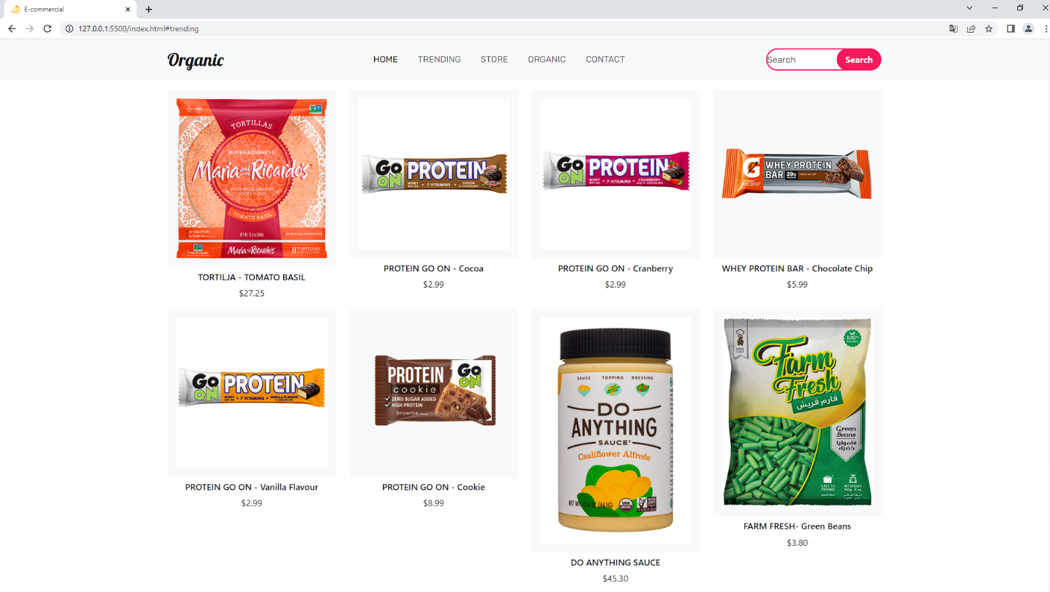

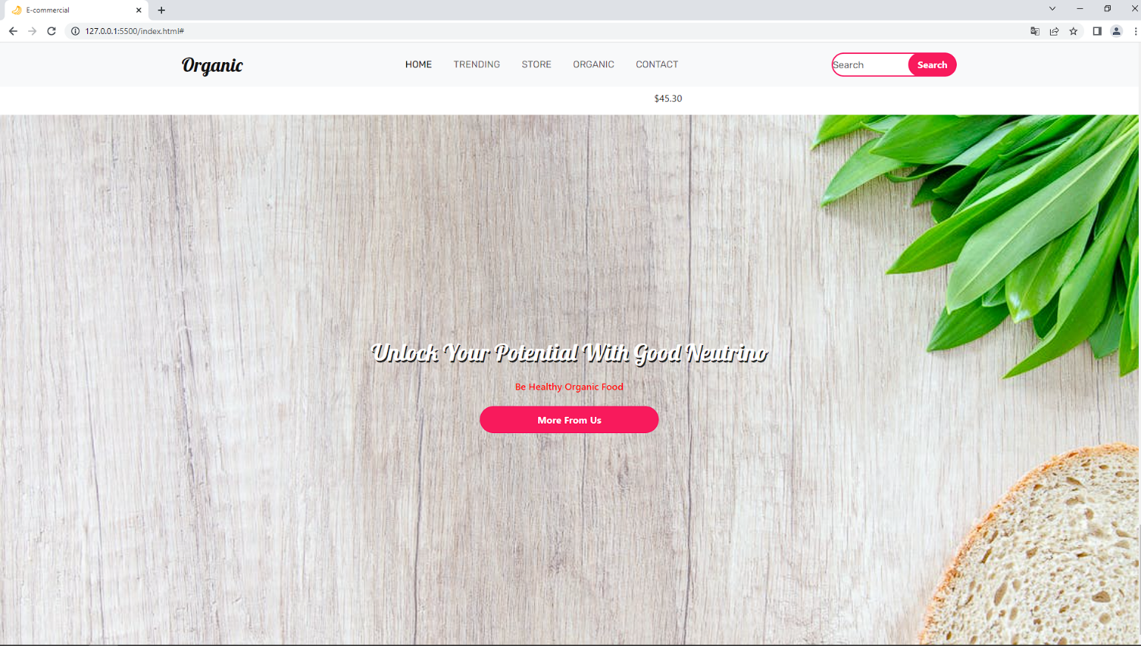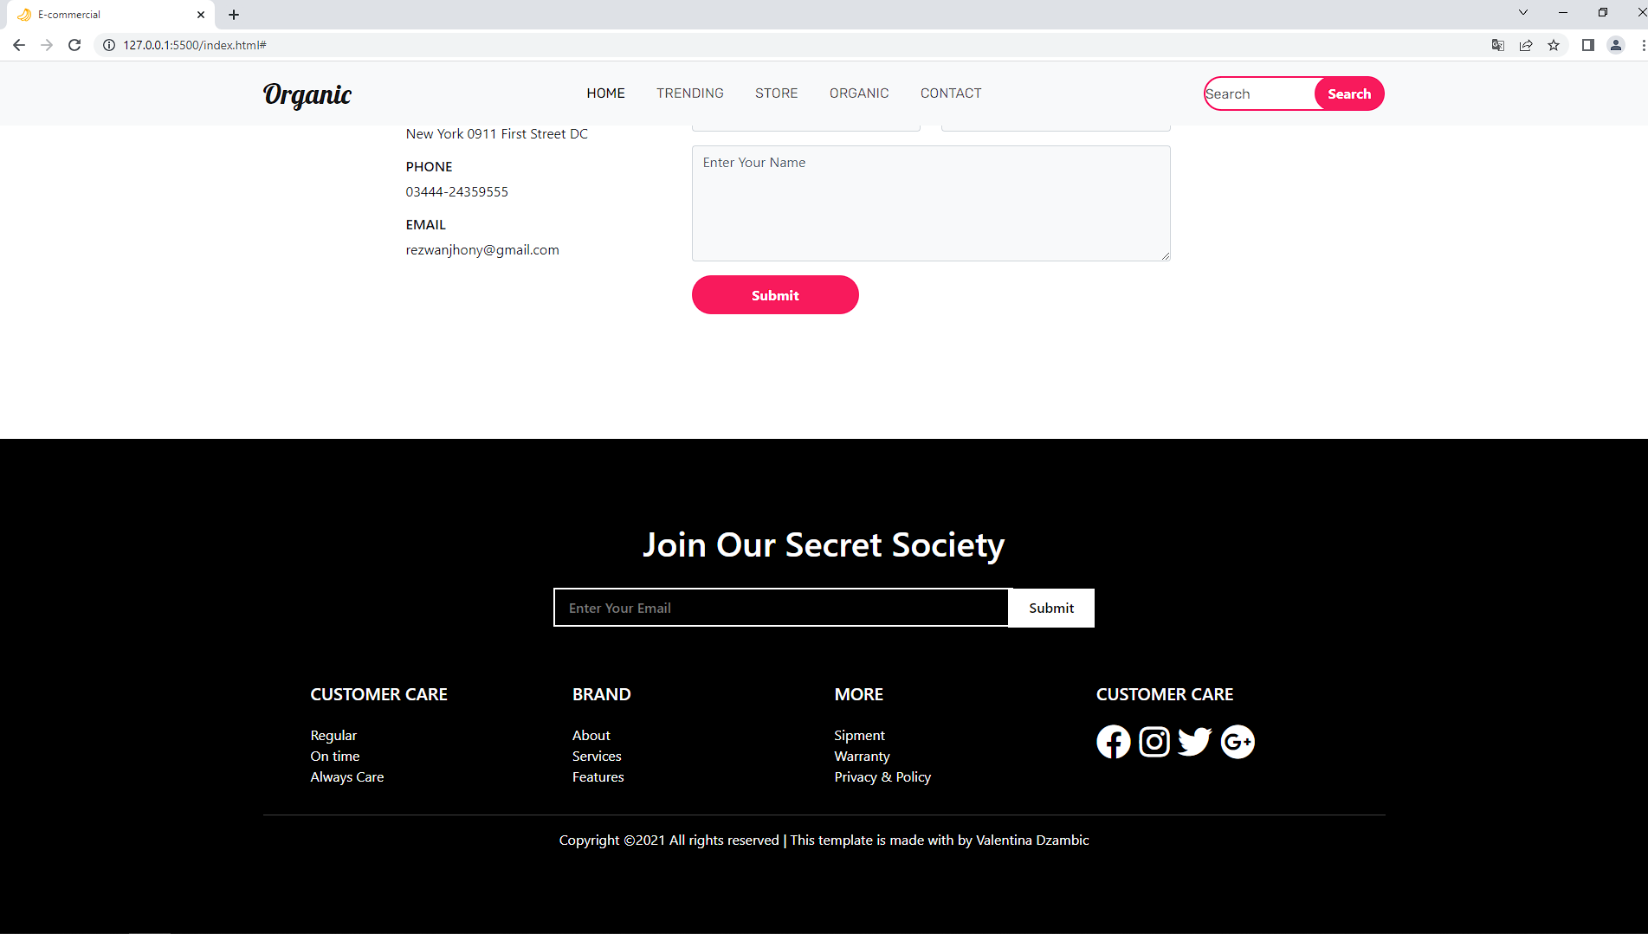

**HTML**

* 1. **Šta je HTML?**

HTML je kompjuterski jezik koji se koristi za kreiranje web sajtova. Njegovo puno ime je *HyperText Markup Language*, tj. jezik za označavanje hiperteksta. Pre nego što nastavimo, valja objasniti prvo da je hiperteskt tekstualna struktura koja se sastoji od međusobno povezanih jedinica informacije.

Reč „hyper” označava da je reč o nelinerarnom prikazu informacija. Drugim rečima, možete da kliknete na bilo koji deo sajta, učitavajući informacije na način koji vama odgovara. To znači da ne postoji pravi početak i kraj, već možete da posećujete šta god poželite. Treba istaći i da je hipertekst modularan, što znači da on praktično nikad nije završen, ali se uvek može nadograditi.

Termin „markup” označava HTML tagove pomoću kojih se detaljnije definiše tekst. To može biti obeležavanje načina na koji se prikazuje tekst, npr. podebljanje slova () ili prebacivanje slova u italik (*). Postoji još mnogo vrsta tagova, pa ćete tokom rada postepeno obogaćivati „vokabular”.*

**1.2 Za šta se koristi HTML?**

HTML koristimo kako bismo na pravi način „objasnili” pregledaču (browseru) kako treba da izgleda sajt. Ukoliko je sve urađeno kako treba, sajt će biti vidljiv korisnicima na način na koji mi to želimo. To se prvenstveno čini unošenjem već pomenutih tagova, koji objašnjavaju kako će izgledati sadržaj na sajtu. Da bi kod funkcionisao, neophodno je da se snimi u html obliku. Na taj način omogućava se pregledaču (Chrome, Edge, Opera...) da ga učita.

Kada browser učita fajl, on ga prebacuje u vizuelni oblik, učitavajući informacije na način na koji smo zamislili. Kako se uvek može desiti neka nepredviđena greška, podrazumeva se da će se izgled i funkcionalnost sajta testirati pre puštanja u rad. Ukoliko tagove niste koristili na pravi način, može doći do vizuelnih grešaka, pa i do toga da stranica ne može ni da se prikaže.

* 1. **Osnovne Sintakse**

**<h1> </h1> -** Naslov, tj. Međunaslovi – može da ide od h1 do h6

**<p> <p> -** Novi paragraf, tj. pasus

**<img> </img> -** Ubacivanje fotografije, potrebno je uneti adresu koja vodi do nje

**<table> </table>** Tabela

**<ul> </ul> -** Neodredjena lista (U nju smeštamo material u listi <li> </li>)

**<li> </li> -** Maretijal u listi

**<input> </input> -** Pravimo prazno polje u kome mozemo da ubacimo tekst (u zavisnosti sta odredimo)

**<b> </b>** Podebljana, tj. boldovana slova

**<i> </i> -** Italik, tj. Kurziv

**<u> </u> -** Podvučen tekst

**<del> </del> -** Precrtana slova

**CSS**

* 1. **Šta je CSS?**

Pored HTML-a, osnovni jezik za kreiranje web sajtova je i CSS. CSS, odnosno Cascading Style Sheets, jezik je koji se koristi za opis prezentacione semantike dokumenata pisanih jezikom oznaka (HTML).

**2.2 Kako se koristi CSS?**

CSS poseduje dva najznačajnija mesta primene:

* uređivanje izgleda i formatiranja svih elemenata u HTML dokumentu;
* definisanje rasporeda i veličine HTML elemenata unutar dokumenta.

CSS je nastao mnogo posle HTML-a. U početku, HTML stranice nisu bile stilizovane. Potom su se koristili HTML tagovi za stilizaciju, što je dodatno povećavalo kompleksnost HTML dokumenata i usložnjavalo održavanje. Upravo zbog toga je osmišljen CSS jezik, čija je primarna uloga da stilizuje HTML dokument, bez mešanja sadržaja i stilizacije. Tako se može reći da je jedna od osnovnih mogućnosti CSS-a definisanje stilizacije nezavisno od sadržaja dokumenta.

* 1. **Osnovne Sintakse**

Ovo je jedan od načina pisanje CSS-a.

div{

color: green;

}

Ovo znači da će svaki div(Koji smo izabrali iz HTML-a) imati zeleni tekst.

**color: -** Boja teksta

**text-align: -** Na koji način želimo da pozicioniramo tekst

**font-size: -** Veličina fonta

**font-weight:** Debljina fonta

**font-family –** Vrsta fonta

**background-color: -** Boja celog zida(slike)

**margine: -** Spoljašnji razmak

**padding: -** Unutrašnji razmak

**border: -** Okvir

**BOOTSTRAP**

* 1. **Šta je BOOTSTRAP?**

**Bootstrap** je open-source JavaScript framework, odnosno kombinacija HTML-a, CSS-a i JavaScript-a, razvijen sa ciljem da omogući i olakša razvoj web formi (interface-a, tj. layout-a) kao i razvoj naprednih web komponenti. Zato ga sa te strane možemo zvati Front-End-Framework.

* 1. **Kako se koristi BOOTSTRAP?**

Bootstrap je, dakle, kolekcija razvijenih CSS i JavaScript alata i biblioteka. Isto tako je modularnog tipa, što omogućava njegovu dalju lakšu „nadogranju“ i upotrebu sa različitim modulima koje izrađuju nezavisni developeri.

Osim što omogućava i olakšava integrisanje raznih vrsta komponenti (formi, buttons-a, akcija sa tekstom, i drugim), odlično „sarađuje“ sa JavaScript-om i sa jQuery bibliotekama.

Omogućava razvoj različitih web formi i interfejsa (layout-ova): grid, fixed, fluid i responsive.

Omogućava rad sa typography-jom, kao na primer integraciju najrazličitijih font ikonica unutar teksta.

* 1. **Osnovne Sintakse**

**SINTAKSE SE NEMOGU KORISTITI AKO NE STAVITE BOOTSTRAP CDN-OVE U HEAD HTML-A!**

**“text-danger” -** Crvena boja

**“text-warning” -** Žuta boja

**“col” -** Kolona

**“xs”** Za telephone ( ekrani su manje širi od 768px)

**“sm” –** Za tablete ( ekrani su isti ili širi od 768px)

**“md” -** Za male laptopove ( ekrani su isti ili širi od 992px)

**“lg” -** Za laptopove i dekstopove ( ekrani su isti ili širi od 1200px)

**“bg” –** Pozadina (*Background*)

**JAVASCRIPT**

* 1. **Šta je JAVASCRIPT-a?**

JavaScript je nastao 1995. godine, inspirisan Java programskim jezikom. U to vreme nije postojao danas najpopularniji browser Google Chrome. Šta više, kompanija Google će biti osnovana tek tri godine kasnije. Tada su internet konekcije bile znatno skromnijih karakteristika.

* 1. **Kako se koristi JAVASCRIPT-a?**

Zbog svojih specifičnih osobina, JavaScript se u velikoj meri koristi pri kreiranju web stranica. On nudi nekoliko ključnih prednosti u odnosu na neke druge programske jezike:

* **Visok nivo interaktivnosti** – moguće je kreirati sadržaj koji se aktivira kada korisnik pređe mišem preko njega ili pritsne dugme na tastaturi;
* **Mogućnost rada u lokalu**– s obzirom na to da je jezik orijentisan ka klijentu, komunikacija sa serverom svedena je na minimum;
* **Bogatiji interfejs** – omogućava kompleksniju strukturu stranice, kao i izvršavanje specifičnih naredbi poput prevlačenja sadržaja;
* **Trenutne povratne informacije** – korisnik ne mora ponovo da učitava stranu da bi video promenu koju je uneo.

To su samo neke od mogućnosti koje nudi JavaScript, ali treba naglasiti da neke operacije namerno nisu moguće zbog bezbednosti.

* 1. **Osnovne Sintakse**

**alert(“hello world”) –** Svaki put kada bi upalili stranicu pojavio bi se mali prozorčić na kome piše *hello world*

**console.log() –** Očitava funkciju u konzoli koju smo ukucali

**let/var -** Koristi se za inicijalizovanje varijable

**const –** Koristi se za inicijalizovanje varijable koja se ne menja

**document.getElementById() –** Uzimamo id iz HTML-a

**document.getElementByClass() –** Uzimamo klasu iz HTML-a

**document.querySelector() –** Moze da uzme id-jeve ili klase iz HTML-a

**KAKO INSTALIRATI I KORISTITI VISUAL STUDIO CODE**

Ispisati taj link u Browser, nakon toga kliknuti *Download for Windows.*

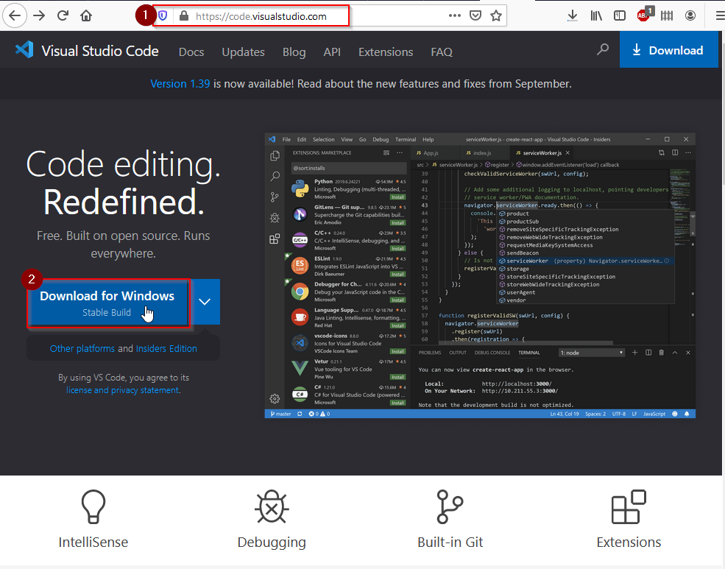

Posle toga ući na 5 ikonicu sa leve strane počevši od gore, ikonica izgleda ovako 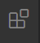.

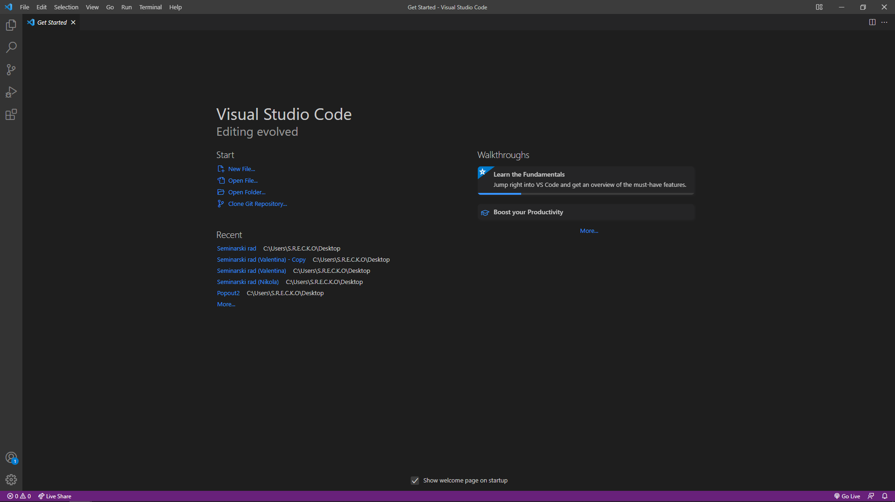

Instalirajte *Live Server* klikom na dugme *Install*.

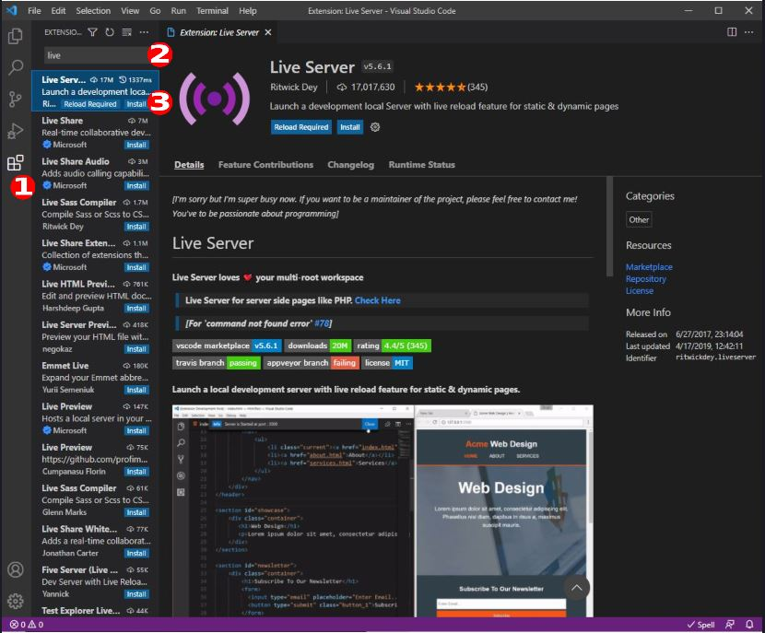

Kada instalirate Live Server udjite u Explorer oznaceno ovom ikonicom .

Na ovaj način dodajemo HTML element.

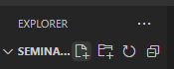

Da bi element bio HTML, moramo nakraju uvek staviti *.html*

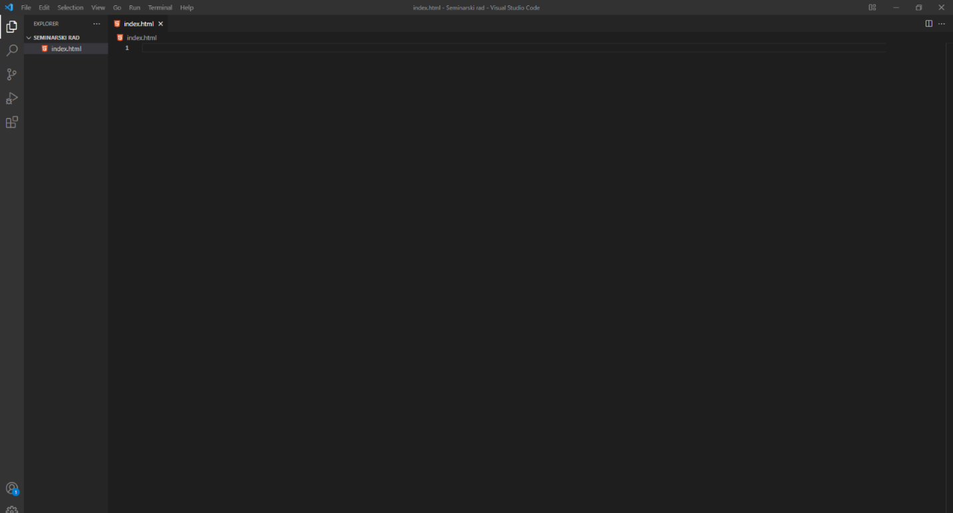

**PISANJE NAŠEG KODA**

**6.1 POSTAVLJANJE BOOTSTRAP CDN-a**

**Index.html**

|  |
| --- |
| **<!DOCTYPE html>**  **<html lang="en">**  **<head>**  **<meta charset="UTF-8">**  **<meta http-equiv="X-UA-Compatible" content="IE=edge">**  **<meta name="viewport" content="width=device-width, initial-scale=1.0">**  **<title>Document</title>**    **<link rel="preconnect" href="https://fonts.googleapis.com" />**  **<link rel="preconnect" href="https://fonts.gstatic.com" crossorigin />**  **<link**  **href="https://fonts.googleapis.com/css2?family=Lobster&family=Oswald:wght@300&family=Rubik&display=swap"**  **rel="stylesheet"**  **/>**  **<link**  **href="https://cdn.jsdelivr.net/npm/bootstrap@5.0.2/dist/css/bootstrap.min.css"**  **rel="stylesheet"**  **integrity="sha384-EVSTQN3/azprG1Anm3QDgpJLIm9Nao0Yz1ztcQTwFspd3yD65VohhpuuCOmLASjC"**  **crossorigin="anonymous"**  **/>**  **<script src="https://kit.fontawesome.com/c26cd2166c.js"></script>**    **</head>**  **<body>**    **</body>**  **</html>** |

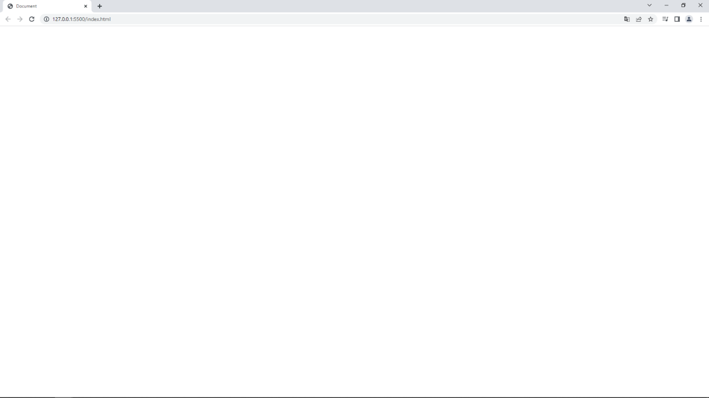

Da bi upalili webrowser preko VSCoda, moramo kliknuti desni klik na VSCode (Na isti prozor gde kodove pisemo) I posle toga kliknuti *Open With Live Serve* (Ili za skraćenicu ALT + L, posle toga ALT + O

**6.2 FOOTER**

**Index.html**

|  |
| --- |
| <!DOCTYPE html>  <html lang="en">  <head>      <meta charset="UTF-8">      <meta http-equiv="X-UA-Compatible" content="IE=edge">      <meta name="viewport" content="width=device-width, initial-scale=1.0">      <title>Document</title>        <link rel="preconnect" href="https://fonts.googleapis.com" />      <link rel="preconnect" href="https://fonts.gstatic.com" crossorigin />      <link        href="https://fonts.googleapis.com/css2?family=Lobster&family=Oswald:wght@300&family=Rubik&display=swap"        rel="stylesheet"      />      <link        href="https://cdn.jsdelivr.net/npm/bootstrap@5.0.2/dist/css/bootstrap.min.css"        rel="stylesheet"        integrity="sha384-EVSTQN3/azprG1Anm3QDgpJLIm9Nao0Yz1ztcQTwFspd3yD65VohhpuuCOmLASjC"        crossorigin="anonymous"      />      <script src="https://kit.fontawesome.com/c26cd2166c.js"></script>    </head>  <body>      **<nav class="navbar fixed-top navbar-expand-lg  navbar-light bg-light">**  **<div class="container">**  **<a class="navbar-brand" href="#">Organic</a>**  **<button**  **class="navbar-toggler"**  **type="button"**  **data-bs-toggle="collapse"**  **data-bs-target="#navbarSupportedContent"**  **aria-controls="navbarSupportedContent"**  **aria-expanded="false"**  **aria-label="Toggle navigation"**  **>**  **<span class="navbar-toggler-icon"></span>**  **</button>**  **<div class="collapse navbar-collapse" id="navbarSupportedContent">**  **<ul class="navbar-nav m-auto mb-2 mb-lg-0">**  **<li class="nav-item">**  **<a class="nav-link active" href="#">Home</a>**  **</li>**  **<li class="nav-item">**  **<a class="nav-link" href="#trending">TRENDING</a>**  **</li>**  **<li class="nav-item">**  **<a class="nav-link" href="#store">Store</a>**  **</li>**  **<li class="nav-item">**  **<a class="nav-link" href="#organic">Organic</a>**  **</li>**  **<li class="nav-item">**  **<a class="nav-link" href="#contact">Contact</a>**  **</li>**  **</ul>**  **<form class="d-flex">**  **<input**  **class="search"**  **type="search"**  **placeholder="Search"**  **aria-label="Search"**  **/>**  **<button class="btn0" type="submit">Search</button>**  **</form>**  **</div>**  **</div>**  **</nav>**  </body>  </html> |

Index.html

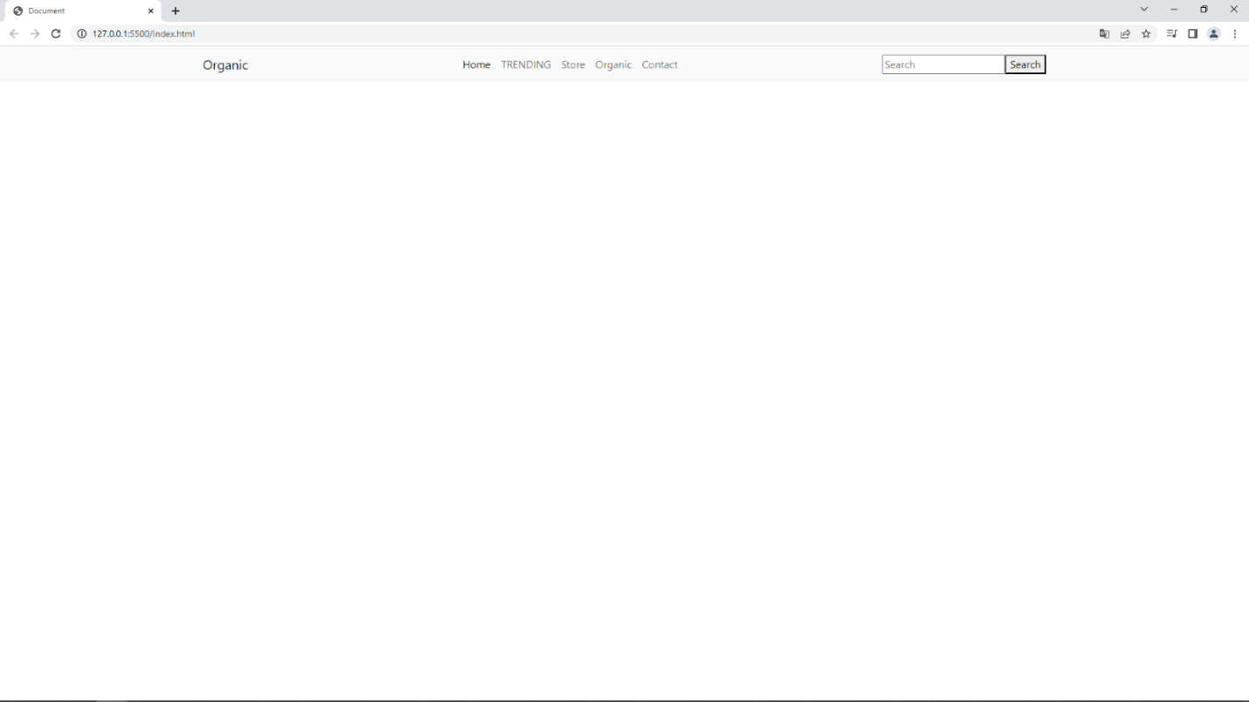

Pravimo footer preko BOOTSTRAPA. Ali trenutno footer neizgleda baš lepo tako da ćemo ga malo stilizovati uz pomoć CSS-a.

**6.3 DODAVANJE CSS-a**

**Index.html**

|  |
| --- |
| <!DOCTYPE html>  <html lang="en">  <head>      <meta charset="UTF-8">      <meta http-equiv="X-UA-Compatible" content="IE=edge">      <meta name="viewport" content="width=device-width, initial-scale=1.0">      **<title>E-commercial</title>**      <link rel="preconnect" href="https://fonts.googleapis.com" />      <link rel="preconnect" href="https://fonts.gstatic.com" crossorigin />      <link        href="https://fonts.googleapis.com/css2?family=Lobster&family=Oswald:wght@300&family=Rubik&display=swap"        rel="stylesheet"      />      <link        href="https://cdn.jsdelivr.net/npm/bootstrap@5.0.2/dist/css/bootstrap.min.css"        rel="stylesheet"        integrity="sha384-EVSTQN3/azprG1Anm3QDgpJLIm9Nao0Yz1ztcQTwFspd3yD65VohhpuuCOmLASjC"        crossorigin="anonymous"      />      <script src="https://kit.fontawesome.com/c26cd2166c.js"></script>   **<link rel="stylesheet" href="style.css" />**  **<link rel="icon" href="./img/banana.png" />**   </head>  <body>      <nav class="navbar fixed-top navbar-expand-lg  navbar-light bg-light">          <div class="container">            <a class="navbar-brand" href="#">Organic</a>            <button              class="navbar-toggler"              type="button"              data-bs-toggle="collapse"              data-bs-target="#navbarSupportedContent"              aria-controls="navbarSupportedContent"              aria-expanded="false"              aria-label="Toggle navigation"            >              <span class="navbar-toggler-icon"></span>            </button>            <div class="collapse navbar-collapse" id="navbarSupportedContent">              <ul class="navbar-nav m-auto mb-2 mb-lg-0">                <li class="nav-item">                  <a class="nav-link active" href="#">Home</a>                </li>                <li class="nav-item">                  <a class="nav-link" href="#trending">TRENDING</a>                </li>                <li class="nav-item">                  <a class="nav-link" href="#store">Store</a>                </li>                <li class="nav-item">                  <a class="nav-link" href="#organic">Organic</a>                </li>                <li class="nav-item">                  <a class="nav-link" href="#contact">Contact</a>                </li>              </ul>              <form class="d-flex">                <input                  class="search"                  type="search"                  placeholder="Search"                  aria-label="Search"                />                <button class="btn0" type="submit">Search</button>              </form>            </div>          </div>        </nav>  </body>  </html> |

**Style.css**

|  |
| --- |
| **\* {**  **padding: 0;**  **margin: 0;**  **box-sizing: border-box;**  **}**    **.navbar-brand {**  **font-size: 2rem;**  **color: black;**  **font-family: "Lobster", cursive;**  **}**    **.navbar-brand:hover {**  **color: black;**  **}**    **.nav-link {**  **margin-right: 10px;**  **margin-left: 10px;**  **color: black;**  **font-family: "Rubik", sans-serif;**  **text-transform: uppercase;**  **}**    **.nav-link:hover {**  **color: black;**  **}**    **.search {**  **height: 40px;**  **width: 80%;**  **border-radius: 60px;**  **outline: none;**  **margin-right: -35px;**  **font-family: "Rubik", sans-serif;**  **border: 2px solid rgb(248, 26, 92);**  **}**    **.btn0 {**  **height: 40px;**  **width: 40%;**  **outline: none;**  **border: none;**  **background: rgb(248, 26, 92);**  **color: white;**  **border-radius: 60px;**  **font-weight: 700;**  **}** |

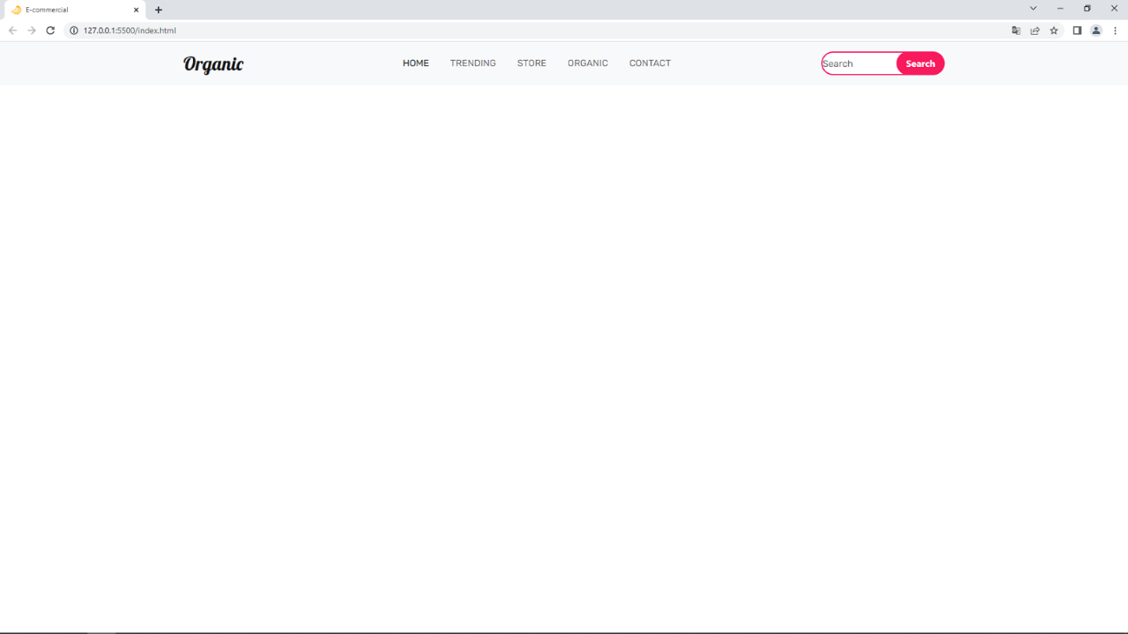

*Style.css*se dodaje na isti način kao i Index.html (samo što je jedina razlika u tome što se na kraju dodaje .css umesto .html). Da bi smo povezali ta dva projekta moramo ih povezati uz pomoć komande <link rel="stylesheet" href="style.css" />.

**6.4 UBACIVANJE SLIKA PREKO CSS-a**

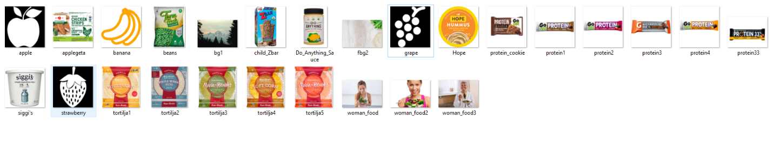

Ovo su slike koje ćemo koristiti na našem sajtu (Preporučljivo je ubaciti jedan folder gde će te držati sve ostale slike).

**Index.html**

|  |
| --- |
| <!DOCTYPE html>  <html lang="en">  <head>      <meta charset="UTF-8">      <meta http-equiv="X-UA-Compatible" content="IE=edge">      <meta name="viewport" content="width=device-width, initial-scale=1.0">        <title>E-commercial</title>      <link rel="preconnect" href="https://fonts.googleapis.com" />      <link rel="preconnect" href="https://fonts.gstatic.com" crossorigin />      <link        href="https://fonts.googleapis.com/css2?family=Lobster&family=Oswald:wght@300&family=Rubik&display=swap"        rel="stylesheet"      />      <link        href="https://cdn.jsdelivr.net/npm/bootstrap@5.0.2/dist/css/bootstrap.min.css"        rel="stylesheet"        integrity="sha384-EVSTQN3/azprG1Anm3QDgpJLIm9Nao0Yz1ztcQTwFspd3yD65VohhpuuCOmLASjC"        crossorigin="anonymous"      />      <script src="https://kit.fontawesome.com/c26cd2166c.js"></script>       <link rel="stylesheet" href="style.css" />      <link rel="icon" href="./img/banana.png" />   </head>  <body>      <nav class="navbar fixed-top navbar-expand-lg  navbar-light bg-light">          <div class="container">            <a class="navbar-brand" href="#">Organic</a>            <button              class="navbar-toggler"              type="button"              data-bs-toggle="collapse"              data-bs-target="#navbarSupportedContent"              aria-controls="navbarSupportedContent"              aria-expanded="false"              aria-label="Toggle navigation"            >              <span class="navbar-toggler-icon"></span>            </button>            <div class="collapse navbar-collapse" id="navbarSupportedContent">              <ul class="navbar-nav m-auto mb-2 mb-lg-0">                <li class="nav-item">                  <a class="nav-link active" href="#">Home</a>                </li>                <li class="nav-item">                  <a class="nav-link" href="#trending">TRENDING</a>                </li>                <li class="nav-item">                  <a class="nav-link" href="#store">Store</a>                </li>                <li class="nav-item">                  <a class="nav-link" href="#organic">Organic</a>                </li>                <li class="nav-item">                  <a class="nav-link" href="#contact">Contact</a>                </li>              </ul>              <form class="d-flex">                <input                  class="search"                  type="search"                  placeholder="Search"                  aria-label="Search"                />                <button class="btn0" type="submit">Search</button>              </form>            </div>          </div>        </nav>         <section class="main">          <div class="container py-5">            <div class="row py-5">              <div class="col-lg-7 pt-5 text-center">                <h1 class="pt-5">Nature Has Always Cared For Us!</h1>                <button class="btn1 mt-3">More Tips</button>              </div>            </div>          </div>        </section>  </body>  </html> |

**Style.css**

|  |
| --- |
| * {      padding: 0;      margin: 0;      box-sizing: border-box;    }      .navbar-brand {      font-size: 2rem;      color: black;      font-family: "Lobster", cursive;    }      .navbar-brand:hover {      color: black;    }      .nav-link {      margin-right: 10px;      margin-left: 10px;      color: black;      font-family: "Rubik", sans-serif;      text-transform: uppercase;    }      .nav-link:hover {      color: black;    }      .search {      height: 40px;      width: 80%;      border-radius: 60px;      outline: none;      margin-right: -35px;      font-family: "Rubik", sans-serif;      border: 2px solid rgb(248, 26, 92);    }      .btn0 {      height: 40px;      width: 40%;      outline: none;      border: none;      background: rgb(248, 26, 92);      color: white;      border-radius: 60px;      font-weight: 700;    }   **.main** {      **background**: url(./img/bg1.jpg) **no-repeat**;      **background**-**size**: cover;      **height**: **100**vh;      **background-position**: **50**% **50**%;      **width**: **100**%;    }      **.main** h1 {      **font-size**: **4**rem;      **font-weight**: **700**;    }      **.btn1** {      **height**: **45px**;      **width**: **35**%;      **border**: **none**;      **outline**: **none**;      **background-color**: **rgb**(**248**, **26**, **92**);      **color**: white;      **font-weight**: **700**;      **border**-radius: **60px**;    }      **.btn1:hover** {      **background-color**: **rgb**(**223**, **15**, **77**);      transition: **0.5s**;    } |

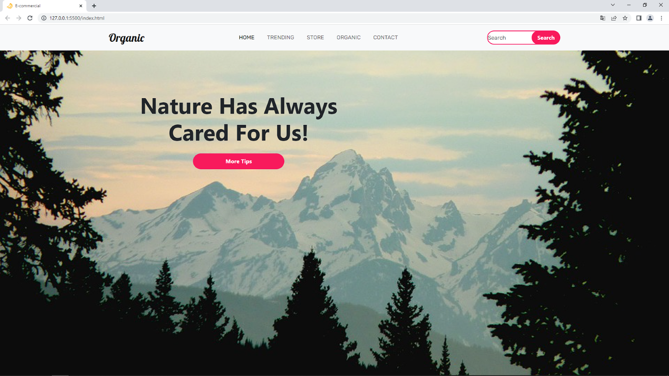

**6.5 UBACIVANJE SLIČICA**

**Index.html**

|  |
| --- |
| <!DOCTYPE html>  <html lang="en">  <head>      <meta charset="UTF-8">      <meta http-equiv="X-UA-Compatible" content="IE=edge">      <meta name="viewport" content="width=device-width, initial-scale=1.0">        <title>E-commercial</title>      <link rel="preconnect" href="https://fonts.googleapis.com" />      <link rel="preconnect" href="https://fonts.gstatic.com" crossorigin />      <link        href="https://fonts.googleapis.com/css2?family=Lobster&family=Oswald:wght@300&family=Rubik&display=swap"        rel="stylesheet"      />      <link        href="https://cdn.jsdelivr.net/npm/bootstrap@5.0.2/dist/css/bootstrap.min.css"        rel="stylesheet"        integrity="sha384-EVSTQN3/azprG1Anm3QDgpJLIm9Nao0Yz1ztcQTwFspd3yD65VohhpuuCOmLASjC"        crossorigin="anonymous"      />      <script src="https://kit.fontawesome.com/c26cd2166c.js"></script>       <link rel="stylesheet" href="style.css" />      <link rel="icon" href="./img/banana.png" />   </head>  <body>      <nav class="navbar fixed-top navbar-expand-lg  navbar-light bg-light">          <div class="container">            <a class="navbar-brand" href="#">Organic</a>            <button              class="navbar-toggler"              type="button"              data-bs-toggle="collapse"              data-bs-target="#navbarSupportedContent"              aria-controls="navbarSupportedContent"              aria-expanded="false"              aria-label="Toggle navigation"            >              <span class="navbar-toggler-icon"></span>            </button>            <div class="collapse navbar-collapse" id="navbarSupportedContent">              <ul class="navbar-nav m-auto mb-2 mb-lg-0">                <li class="nav-item">                  <a class="nav-link active" href="#">Home</a>                </li>                <li class="nav-item">                  <a class="nav-link" href="#trending">TRENDING</a>                </li>                <li class="nav-item">                  <a class="nav-link" href="#store">Store</a>                </li>                <li class="nav-item">                  <a class="nav-link" href="#organic">Organic</a>                </li>                <li class="nav-item">                  <a class="nav-link" href="#contact">Contact</a>                </li>              </ul>              <form class="d-flex">                <input                  class="search"                  type="search"                  placeholder="Search"                  aria-label="Search"                />                <button class="btn0" type="submit">Search</button>              </form>            </div>          </div>        </nav>         <section class="main">          <div class="container py-5">            <div class="row py-5">              <div class="col-lg-7 pt-5 text-center">                <h1 class="pt-5">Nature Has Always Cared For Us!</h1>                <button class="btn1 mt-3">More Tips</button>              </div>            </div>          </div>        </section>      **<section class="new">**  **<div class="container py-5">**  **<div class="row pt-5">**  **<div class="col-lg-7 m-auto">**  **<div class="row text-center">**  **<div class="col-lg-4">**  **<img src="./img/strawberry.png" class="img-luid" alt="" />**  **<h6>NATURAL</h6>**  **</div>**  **<div class="col-lg-4">**  **<img src="./img/grape.png" class="img-luid" alt="" />**  **<h6>ORGANIC</h6>**  **</div>**  **<div class="col-lg-4">**  **<img src="./img/apple.png" class="img-luid" alt="" />**  **<h6>HEALTH</h6>**  **</div>**  **</div>**  **</div>**  **</div>**  **</div>**  **</section>**  </body>  </html> |

**Style.css**

|  |
| --- |
| * {      padding: 0;      margin: 0;      box-sizing: border-box;    }      .navbar-brand {      font-size: 2rem;      color: black;      font-family: "Lobster", cursive;    }      .navbar-brand:hover {      color: black;    }      .nav-link {      margin-right: 10px;      margin-left: 10px;      color: black;      font-family: "Rubik", sans-serif;      text-transform: uppercase;    }      .nav-link:hover {      color: black;    }      .search {      height: 40px;      width: 80%;      border-radius: 60px;      outline: none;      margin-right: -35px;      font-family: "Rubik", sans-serif;      border: 2px solid rgb(248, 26, 92);    }      .btn0 {      height: 40px;      width: 40%;      outline: none;      border: none;      background: rgb(248, 26, 92);      color: white;      border-radius: 60px;      font-weight: 700;    }   .main {      background: url(./img/bg1.jpg) no-repeat;      background-size: cover;      height: 100vh;      background-position: 50% 50%;      width: 100%;    }      .main h1 {      font-size: 4rem;      font-weight: 700;    }      .btn1 {      height: 45px;      width: 35%;      border: none;      outline: none;      background-color: rgb(248, 26, 92);      color: white;      font-weight: 700;      border-radius: 60px;    }      .btn1:hover {      background-color: rgb(223, 15, 77);      transition: 0.5s;    } |

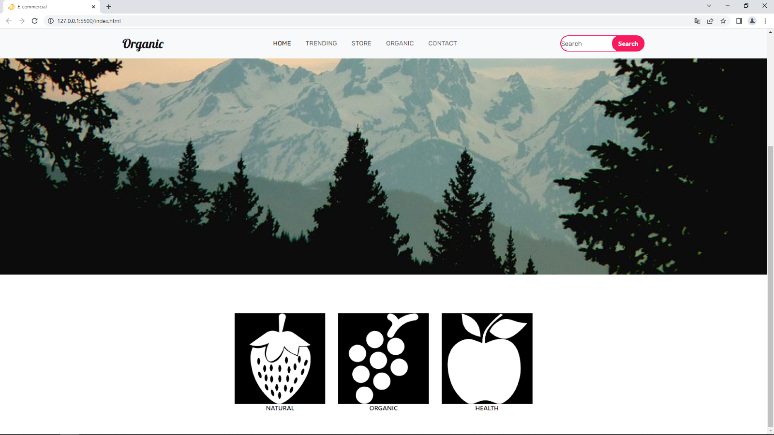

**6.6 TRENDING**

**Index.html**

|  |
| --- |
| <!DOCTYPE html>  <html lang="en">  <head>      <meta charset="UTF-8">      <meta http-equiv="X-UA-Compatible" content="IE=edge">      <meta name="viewport" content="width=device-width, initial-scale=1.0">        <title>E-commercial</title>      <link rel="preconnect" href="https://fonts.googleapis.com" />      <link rel="preconnect" href="https://fonts.gstatic.com" crossorigin />      <link        href="https://fonts.googleapis.com/css2?family=Lobster&family=Oswald:wght@300&family=Rubik&display=swap"        rel="stylesheet"      />      <link        href="https://cdn.jsdelivr.net/npm/bootstrap@5.0.2/dist/css/bootstrap.min.css"        rel="stylesheet"        integrity="sha384-EVSTQN3/azprG1Anm3QDgpJLIm9Nao0Yz1ztcQTwFspd3yD65VohhpuuCOmLASjC"        crossorigin="anonymous"      />      <script src="https://kit.fontawesome.com/c26cd2166c.js"></script>       <link rel="stylesheet" href="style.css" />      <link rel="icon" href="./img/banana.png" />   </head>  <body>      <nav class="navbar fixed-top navbar-expand-lg  navbar-light bg-light">          <div class="container">            <a class="navbar-brand" href="#">Organic</a>            <button              class="navbar-toggler"              type="button"              data-bs-toggle="collapse"              data-bs-target="#navbarSupportedContent"              aria-controls="navbarSupportedContent"              aria-expanded="false"              aria-label="Toggle navigation"            >              <span class="navbar-toggler-icon"></span>            </button>            <div class="collapse navbar-collapse" id="navbarSupportedContent">              <ul class="navbar-nav m-auto mb-2 mb-lg-0">                <li class="nav-item">                  <a class="nav-link active" href="#">Home</a>                </li>                <li class="nav-item">                  <a class="nav-link" href="#trending">TRENDING</a>                </li>                <li class="nav-item">                  <a class="nav-link" href="#store">Store</a>                </li>                <li class="nav-item">                  <a class="nav-link" href="#organic">Organic</a>                </li>                <li class="nav-item">                  <a class="nav-link" href="#contact">Contact</a>                </li>              </ul>              <form class="d-flex">                <input                  class="search"                  type="search"                  placeholder="Search"                  aria-label="Search"                />                <button class="btn0" type="submit">Search</button>              </form>            </div>          </div>        </nav>         <section class="main">          <div class="container py-5">            <div class="row py-5">              <div class="col-lg-7 pt-5 text-center">                <h1 class="pt-5">Nature Has Always Cared For Us!</h1>                <button class="btn1 mt-3">More Tips</button>              </div>            </div>          </div>        </section>           <section class="new">          <div class="container py-5">            <div class="row pt-5">              <div class="col-lg-7 m-auto">                <div class="row text-center">                  <div class="col-lg-4">                    <img src="./img/strawberry.png" class="img-luid" alt="" />                    <h6>NATURAL</h6>                  </div>                  <div class="col-lg-4">                    <img src="./img/grape.png" class="img-luid" alt="" />                    <h6>ORGANIC</h6>                  </div>                  <div class="col-lg-4">                    <img src="./img/apple.png" class="img-luid" alt="" />                    <h6>HEALTH</h6>                  </div>                </div>              </div>            </div>          </div>        </section>    **<section class="product " id="trending">**  **<div class="container py-5 ">**  **<div class="row py-5 ">**  **<div class="col-lg-5 m-auto text-center ">**  **<h1>What's Trending</h1>**  **<h6 style="color: red  ">Be Healthy Organic Food</h6>**  **</div>**  **</div>**  **<div class="row">**  **<div class="col-lg-3 text-center">**  **<div class="card border-0 bg-light mb-2">**  **<div class="card-body">**  **<img src="./img/applegeta.png" class="img-fluid" alt="" />**  **</div>**  **</div>**  **<h6>Applegeta</h6>**  **<div class="price">$5.22 <span> $7.22</span></div>**  **</div>**  **<div class="col-lg-3 text-center">**  **<div class="card border-0 bg-light mb-2">**  **<div class="card-body">**  **<img src="./img/child_Zbar.webp" class="img-fluid" alt="" />**  **</div>**  **</div>**  **<h6>Zbar</h6>**  **<div class="price">$15.98 <span> $21.95</span></div>**  **</div>**  **<div class="col-lg-3 text-center">**  **<div class="card border-0 bg-light mb-2">**  **<div class="card-body">**  **<img src="./img/Hope.png" class="img-fluid" alt="" />**  **</div>**  **</div>**  **<h6>HOPE</h6>**  **<div class="price">$2.89 <span> $4.89</span></div>**  **</div>**  **<div class="col-lg-3 text-center">**  **<div class="card border-0 bg-light mb-2">**  **<div class="card-body">**  **<img src="./img/siggi's.png" class="img-fluid" alt="" />**  **</div>**  **</div>**  **<h6>Siggi's</h6>**  **<div class="price">$1.80 <span> $2</span></div>**  **</div>**  **</div>**  **<div class="row">**  **<div class="col-lg-6 text-center m-auto mt-5">**  **<button class="btn1">Click For More</button>**  **</div>**  **</div>**  **</div>**  **</section>**  </body>  </html> |

**Style.css**

|  |
| --- |
| * {      padding: 0;      margin: 0;      box-sizing: border-box;    }      .navbar-brand {      font-size: 2rem;      color: black;      font-family: "Lobster", cursive;    }      .navbar-brand:hover {      color: black;    }      .nav-link {      margin-right: 10px;      margin-left: 10px;      color: black;      font-family: "Rubik", sans-serif;      text-transform: uppercase;    }      .nav-link:hover {      color: black;    }      .search {      height: 40px;      width: 80%;      border-radius: 60px;      outline: none;      margin-right: -35px;      font-family: "Rubik", sans-serif;      border: 2px solid rgb(248, 26, 92);    }      .btn0 {      height: 40px;      width: 40%;      outline: none;      border: none;      background: rgb(248, 26, 92);      color: white;      border-radius: 60px;      font-weight: 700;    }     .main {      background: url(./img/bg1.jpg) no-repeat;      background-size: cover;      height: 100vh;      background-position: 50% 50%;      width: 100%;    }      .main h1 {      font-size: 4rem;      font-weight: 700;    }      .btn1 {      height: 45px;      width: 35%;      border: none;      outline: none;      background-color: rgb(248, 26, 92);      color: white;      font-weight: 700;      border-radius: 60px;    }      .btn1:hover {      background-color: rgb(223, 15, 77);      transition: 0.5s;    }      h1 {      **font-weight**: **700px**;    }      **.card:hover** {      box-shadow: **-2px** **-1px** **25px** **-4px** rgba(**0**, **0**, **0**, **0**.**75**);      -webkit-box-shadow: **-2px** **-1px** **25px** **-4px** rgba(**0**, **0**, **0**, **0**.**75**);      -moz-box-shadow: **-2px** **-1px** **25px** **-4px** rgba(**0**, **0**, **0**, **0**.**75**);      transition: **0.5s**;    }      **.price** span{      **text-decoration**: **line-through**;    } |

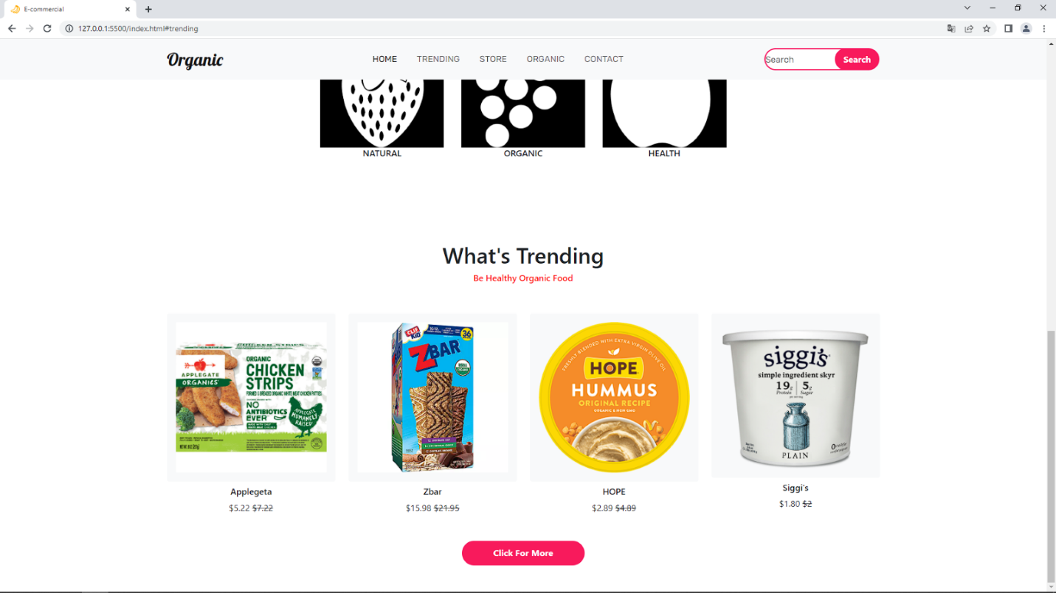

*Hover* u CSS-u znači da kada stavimo miš na to mesto, nešto će se promeniti u zavisnosti šta stavimo unutra. *Transition* je brzina kojom se to nešto dešava.

**6.7 WELCOME TO OUR ORGANIC SOCIAITY**

**Index.html**

|  |
| --- |
| <!DOCTYPE html>  <html lang="en">  <head>      <meta charset="UTF-8">      <meta http-equiv="X-UA-Compatible" content="IE=edge">      <meta name="viewport" content="width=device-width, initial-scale=1.0">        <title>E-commercial</title>      <link rel="preconnect" href="https://fonts.googleapis.com" />      <link rel="preconnect" href="https://fonts.gstatic.com" crossorigin />      <link        href="https://fonts.googleapis.com/css2?family=Lobster&family=Oswald:wght@300&family=Rubik&display=swap"        rel="stylesheet"      />      <link        href="https://cdn.jsdelivr.net/npm/bootstrap@5.0.2/dist/css/bootstrap.min.css"        rel="stylesheet"        integrity="sha384-EVSTQN3/azprG1Anm3QDgpJLIm9Nao0Yz1ztcQTwFspd3yD65VohhpuuCOmLASjC"        crossorigin="anonymous"      />      <script src="https://kit.fontawesome.com/c26cd2166c.js"></script>       <link rel="stylesheet" href="style.css" />      <link rel="icon" href="./img/banana.png" />   </head>  <body>      <nav class="navbar fixed-top navbar-expand-lg  navbar-light bg-light">          <div class="container">            <a class="navbar-brand" href="#">Organic</a>            <button              class="navbar-toggler"              type="button"              data-bs-toggle="collapse"              data-bs-target="#navbarSupportedContent"              aria-controls="navbarSupportedContent"              aria-expanded="false"              aria-label="Toggle navigation"            >              <span class="navbar-toggler-icon"></span>            </button>            <div class="collapse navbar-collapse" id="navbarSupportedContent">              <ul class="navbar-nav m-auto mb-2 mb-lg-0">                <li class="nav-item">                  <a class="nav-link active" href="#">Home</a>                </li>                <li class="nav-item">                  <a class="nav-link" href="#trending">TRENDING</a>                </li>                <li class="nav-item">                  <a class="nav-link" href="#store">Store</a>                </li>                <li class="nav-item">                  <a class="nav-link" href="#organic">Organic</a>                </li>                <li class="nav-item">                  <a class="nav-link" href="#contact">Contact</a>                </li>              </ul>              <form class="d-flex">                <input                  class="search"                  type="search"                  placeholder="Search"                  aria-label="Search"                />                <button class="btn0" type="submit">Search</button>              </form>            </div>          </div>        </nav>         <section class="main">          <div class="container py-5">            <div class="row py-5">              <div class="col-lg-7 pt-5 text-center">                <h1 class="pt-5">Nature Has Always Cared For Us!</h1>                <button class="btn1 mt-3">More Tips</button>              </div>            </div>          </div>        </section>           <section class="new">          <div class="container py-5">            <div class="row pt-5">              <div class="col-lg-7 m-auto">                <div class="row text-center">                  <div class="col-lg-4">                    <img src="./img/strawberry.png" class="img-luid" alt="" />                    <h6>NATURAL</h6>                  </div>                  <div class="col-lg-4">                    <img src="./img/grape.png" class="img-luid" alt="" />                    <h6>ORGANIC</h6>                  </div>                  <div class="col-lg-4">                    <img src="./img/apple.png" class="img-luid" alt="" />                    <h6>HEALTH</h6>                  </div>                </div>              </div>            </div>          </div>        </section>    <section class="product " id="trending">          <div class="container py-5 ">            <div class="row py-5 ">              <div class="col-lg-5 m-auto text-center ">                <h1>What's Trending</h1>                <h6 style="color: red  ">Be Healthy Organic Food</h6>              </div>            </div>            <div class="row">              <div class="col-lg-3 text-center">                <div class="card border-0 bg-light mb-2">                  <div class="card-body">                    <img src="./img/applegeta.png" class="img-fluid" alt="" />                  </div>                </div>                <h6>Applegeta</h6>                <div class="price">$5.22 <span> $7.22</span></div>              </div>              <div class="col-lg-3 text-center">                <div class="card border-0 bg-light mb-2">                  <div class="card-body">                    <img src="./img/child_Zbar.webp" class="img-fluid" alt="" />                  </div>                </div>                <h6>Zbar</h6>                <div class="price">$15.98 <span> $21.95</span></div>              </div>              <div class="col-lg-3 text-center">                <div class="card border-0 bg-light mb-2">                  <div class="card-body">                    <img src="./img/Hope.png" class="img-fluid" alt="" />                  </div>                </div>                <h6>HOPE</h6>                <div class="price">$2.89 <span> $4.89</span></div>              </div>              <div class="col-lg-3 text-center">                <div class="card border-0 bg-light mb-2">                  <div class="card-body">                    <img src="./img/siggi's.png" class="img-fluid" alt="" />                  </div>                </div>                <h6>Siggi's</h6>                <div class="price">$1.80 <span> $2</span></div>              </div>            </div>            <div class="row">              <div class="col-lg-6 text-center m-auto mt-5">                <button class="btn1">Click For More</button>              </div>            </div>          </div>        </section>    **<section class="about ">**  **<div class="container py-5">**  **<div class="row py-5">**  **<div class="col-lg-8 m-auto text-center">**  **<h1>Welcome to our Organic Food Sociaty</h1>**  **<h6 style="color: red">Be Healthy Organic Food</h6>**  **</div>**  **</div>**  **<div class="row">**  **<div class="col-lg-4">**  **<img src="./img/woman_food.webp" class="img-fluid mb-3" alt="" />**  **<h5>BEAT MALNUTRITION AND**  **NONCOMMUNICABLE DISEASES</h5>**  **<p>**  **A healthy diet helps protect against**  **malnutrition in all its forms, as well**  **as diet-related noncommunicable**  **diseases, including diabetes, heart**  **disease, stroke and cancer**  **</p>**  **</div>**  **<div class="col-lg-4">**  **<img src="./img/woman_food2.png" class="img-fluid mb-3" alt="" />**  **<h5>GLOBAL RISKS</h5>**  **<p>**  **Unhealthy diet and lack of physical**  **activity are leading global risks to**  **health.**  **</p>**  **</div>**  **<div class="col-lg-4">**  **<img src="./img/woman_food3.jpg" class="img-fluid mb-3" alt="" />**  **<h5>START EARLY IN LIFE</h5>**  **<p>**  **Healthy dietary practices start early**  **in life - breastfeeding fosters healthy**  **growth and improves cognitive**  **development, and may have longerterm health benefits like reducing the**  **risk of becoming overweight or obese**  **and developing noncommunicable**  **diseases later in life.**  **</p>**  **</div>**  **</div>**  **<div class="row pt-3">**  **<div class="col-lg-6 text-center m-auto">**  **<button class="btn1">Shop More</button>**  **</div>**  **</div>**  **</div>**  **</section>**  </body>  </html> |

**Style.css**

|  |
| --- |
| * {      padding: 0;      margin: 0;      box-sizing: border-box;    }      .navbar-brand {      font-size: 2rem;      color: black;      font-family: "Lobster", cursive;    }      .navbar-brand:hover {      color: black;    }      .nav-link {      margin-right: 10px;      margin-left: 10px;      color: black;      font-family: "Rubik", sans-serif;      text-transform: uppercase;    }      .nav-link:hover {      color: black;    }      .search {      height: 40px;      width: 80%;      border-radius: 60px;      outline: none;      margin-right: -35px;      font-family: "Rubik", sans-serif;      border: 2px solid rgb(248, 26, 92);    }      .btn0 {      height: 40px;      width: 40%;      outline: none;      border: none;      background: rgb(248, 26, 92);      color: white;      border-radius: 60px;      font-weight: 700;    }     .main {      background: url(./img/bg1.jpg) no-repeat;      background-size: cover;      height: 100vh;      background-position: 50% 50%;      width: 100%;    }      .main h1 {      font-size: 4rem;      font-weight: 700;    }      .btn1 {      height: 45px;      width: 35%;      border: none;      outline: none;      background-color: rgb(248, 26, 92);      color: white;      font-weight: 700;      border-radius: 60px;    }      .btn1:hover {      background-color: rgb(223, 15, 77);      transition: 0.5s;    }      h1 {      **font-weight**: **700px**;    }      **.card:hover** {      box-shadow: **-2px** **-1px** **25px** **-4px** rgba(**0**, **0**, **0**, **0**.**75**);      -webkit-box-shadow: **-2px** **-1px** **25px** **-4px** rgba(**0**, **0**, **0**, **0**.**75**);      -moz-box-shadow: **-2px** **-1px** **25px** **-4px** rgba(**0**, **0**, **0**, **0**.**75**);      transition: **0.5s**;    }      **.price** span{      **text-decoration**: **line-through**;    } |

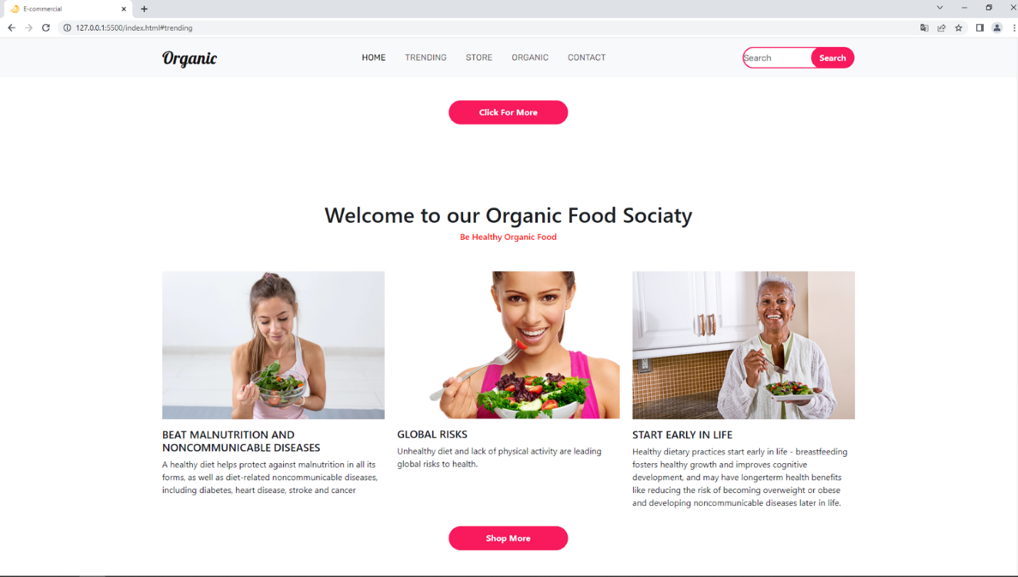

**6.8 STORE**

**Index.html**

|  |
| --- |
| <!DOCTYPE html>  <html lang="en">  <head>      <meta charset="UTF-8">      <meta http-equiv="X-UA-Compatible" content="IE=edge">      <meta name="viewport" content="width=device-width, initial-scale=1.0">        <title>E-commercial</title>      <link rel="preconnect" href="https://fonts.googleapis.com" />      <link rel="preconnect" href="https://fonts.gstatic.com" crossorigin />      <link        href="https://fonts.googleapis.com/css2?family=Lobster&family=Oswald:wght@300&family=Rubik&display=swap"        rel="stylesheet"      />      <link        href="https://cdn.jsdelivr.net/npm/bootstrap@5.0.2/dist/css/bootstrap.min.css"        rel="stylesheet"        integrity="sha384-EVSTQN3/azprG1Anm3QDgpJLIm9Nao0Yz1ztcQTwFspd3yD65VohhpuuCOmLASjC"        crossorigin="anonymous"      />      <script src="https://kit.fontawesome.com/c26cd2166c.js"></script>       <link rel="stylesheet" href="style.css" />      <link rel="icon" href="./img/banana.png" />   </head>  <body>      <nav class="navbar fixed-top navbar-expand-lg  navbar-light bg-light">          <div class="container">            <a class="navbar-brand" href="#">Organic</a>            <button              class="navbar-toggler"              type="button"              data-bs-toggle="collapse"              data-bs-target="#navbarSupportedContent"              aria-controls="navbarSupportedContent"              aria-expanded="false"              aria-label="Toggle navigation"            >              <span class="navbar-toggler-icon"></span>            </button>            <div class="collapse navbar-collapse" id="navbarSupportedContent">              <ul class="navbar-nav m-auto mb-2 mb-lg-0">                <li class="nav-item">                  <a class="nav-link active" href="#">Home</a>                </li>                <li class="nav-item">                  <a class="nav-link" href="#trending">TRENDING</a>                </li>                <li class="nav-item">                  <a class="nav-link" href="#store">Store</a>                </li>                <li class="nav-item">                  <a class="nav-link" href="#organic">Organic</a>                </li>                <li class="nav-item">                  <a class="nav-link" href="#contact">Contact</a>                </li>              </ul>              <form class="d-flex">                <input                  class="search"                  type="search"                  placeholder="Search"                  aria-label="Search"                />                <button class="btn0" type="submit">Search</button>              </form>            </div>          </div>        </nav>         <section class="main">          <div class="container py-5">            <div class="row py-5">              <div class="col-lg-7 pt-5 text-center">                <h1 class="pt-5">Nature Has Always Cared For Us!</h1>                <button class="btn1 mt-3">More Tips</button>              </div>            </div>          </div>        </section>           <section class="new">          <div class="container py-5">            <div class="row pt-5">              <div class="col-lg-7 m-auto">                <div class="row text-center">                  <div class="col-lg-4">                    <img src="./img/strawberry.png" class="img-luid" alt="" />                    <h6>NATURAL</h6>                  </div>                  <div class="col-lg-4">                    <img src="./img/grape.png" class="img-luid" alt="" />                    <h6>ORGANIC</h6>                  </div>                  <div class="col-lg-4">                    <img src="./img/apple.png" class="img-luid" alt="" />                    <h6>HEALTH</h6>                  </div>                </div>              </div>            </div>          </div>        </section>            <section class="product " id="trending">          <div class="container py-5 ">            <div class="row py-5 ">              <div class="col-lg-5 m-auto text-center ">                <h1>What's Trending</h1>                <h6 style="color: red  ">Be Healthy Organic Food</h6>              </div>            </div>            <div class="row">              <div class="col-lg-3 text-center">                <div class="card border-0 bg-light mb-2">                  <div class="card-body">                    <img src="./img/applegeta.png" class="img-fluid" alt="" />                  </div>                </div>                <h6>Applegeta</h6>                <div class="price">$5.22 <span> $7.22</span></div>              </div>              <div class="col-lg-3 text-center">                <div class="card border-0 bg-light mb-2">                  <div class="card-body">                    <img src="./img/child_Zbar.webp" class="img-fluid" alt="" />                  </div>                </div>                <h6>Zbar</h6>                <div class="price">$15.98 <span> $21.95</span></div>              </div>              <div class="col-lg-3 text-center">                <div class="card border-0 bg-light mb-2">                  <div class="card-body">                    <img src="./img/Hope.png" class="img-fluid" alt="" />                  </div>                </div>                <h6>HOPE</h6>                <div class="price">$2.89 <span> $4.89</span></div>              </div>              <div class="col-lg-3 text-center">                <div class="card border-0 bg-light mb-2">                  <div class="card-body">                    <img src="./img/siggi's.png" class="img-fluid" alt="" />                  </div>                </div>                <h6>Siggi's</h6>                <div class="price">$1.80 <span> $2</span></div>              </div>            </div>            <div class="row">              <div class="col-lg-6 text-center m-auto mt-5">                <button class="btn1">Click For More</button>              </div>            </div>          </div>        </section>            <section class="about ">          <div class="container py-5">            <div class="row py-5">              <div class="col-lg-8 m-auto text-center">                <h1>Welcome to our Organic Food Sociaty</h1>                <h6 style="color: red">Be Healthy Organic Food</h6>              </div>            </div>            <div class="row">              <div class="col-lg-4">                <img src="./img/woman_food.webp" class="img-fluid mb-3" alt="" />                <h5>BEAT MALNUTRITION AND                  NONCOMMUNICABLE DISEASES</h5>                <p>                  A healthy diet helps protect against                  malnutrition in all its forms, as well                  as diet-related noncommunicable                  diseases, including diabetes, heart                  disease, stroke and cancer                </p>              </div>              <div class="col-lg-4">                <img src="./img/woman_food2.png" class="img-fluid mb-3" alt="" />                <h5>GLOBAL RISKS</h5>                <p>                  Unhealthy diet and lack of physical                  activity are leading global risks to                  health.                </p>              </div>              <div class="col-lg-4">                <img src="./img/woman_food3.jpg" class="img-fluid mb-3" alt="" />                <h5>START EARLY IN LIFE</h5>                <p>                  Healthy dietary practices start early                  in life - breastfeeding fosters healthy                  growth and improves cognitive                  development, and may have longerterm health benefits like reducing the                  risk of becoming overweight or obese                  and developing noncommunicable                  diseases later in life.                </p>              </div>            </div>            <div class="row pt-3">              <div class="col-lg-6 text-center m-auto">                <button class="btn1">Shop More</button>              </div>            </div>          </div>        </section>      **<section class="shop " id="store">**  **<div class="container">**  **<div class="row py-5">**  **<div class="col-lg-8 m-auto text-center">**  **<h1>Explore Our Store</h1>**  **<h6 style="color: red">Pick Your Product From Our Store</h6>**  **</div>**  **</div>**  **<div class="row">**  **<div class="col-lg-3 text-center">**  **<div class="card border-0 bg-light mb-2">**  **<div class="card-body">**  **<img src="./img/tortilja1.png" class="img-fluid" alt="" />**  **</div>**  **</div>**  **<h6>TORTILJA - WHITE CORN</h6>**  **<p>$30.90</p>**  **</div>**  **<div class="col-lg-3 text-center">**  **<div class="card border-0 bg-light mb-2">**  **<div class="card-body">**  **<img src="./img/tortilja2.webp" class="img-fluid" alt="" />**  **</div>**  **</div>**  **<h6>TORTILJA - WHOLE WHEAT PLUS</h6>**  **<p>$27.45</p>**  **</div>**  **<div class="col-lg-3 text-center">**  **<div class="card border-0 bg-light mb-2">**  **<div class="card-body">**  **<img src="./img/tortilja3.png" class="img-fluid" alt="" />**  **</div>**  **</div>**  **<h6>TORTILJA - SPINACH</h6>**  **<p>$28.20</p>**  **</div>**  **<div class="col-lg-3 text-center">**  **<div class="card border-0 bg-light mb-2">**  **<div class="card-body">**  **<img src="./img/tortilja4.png" class="img-fluid" alt="" />**  **</div>**  **</div>**  **<h6>TORTILJA - SOFT CORN</h6>**  **<p>$25.65</p>**  **</div>**  **<div class="col-lg-3 text-center">**  **<div class="card border-0 bg-light mb-2">**  **<div class="card-body">**  **<img src="./img/tortilja5.png" class="img-fluid" alt="" />**  **</div>**  **</div>**  **<h6>TORTILJA - TOMATO BASIL</h6>**  **<p>$27.25</p>**  **</div>**  **<div class="col-lg-3 text-center">**  **<div class="card border-0 bg-light mb-2">**  **<div class="card-body">**  **<img src="./img/protein1.png" class="img-fluid" alt="" />**  **</div>**  **</div>**  **<h6>PROTEIN GO ON - Cocoa</h6>**  **<p>$2.99</p>**  **</div>**  **<div class="col-lg-3 text-center">**  **<div class="card border-0 bg-light mb-2">**  **<div class="card-body">**  **<img src="./img/protein2.jpg" class="img-fluid" alt="" />**  **</div>**  **</div>**  **<h6>PROTEIN GO ON - Cranberry</h6>**  **<p>$2.99</p>**  **</div>**  **<div class="col-lg-3 text-center">**  **<div class="card border-0 bg-light mb-2">**  **<div class="card-body">**  **<img src="./img/protein3.png" class="img-fluid" alt="" />**  **</div>**  **</div>**  **<h6>WHEY PROTEIN BAR - Chocolate Chip</h6>**  **<p>$5.99</p>**  **</div>**  **<div class="col-lg-3 text-center">**  **<div class="card border-0 bg-light mb-2">**  **<div class="card-body">**  **<img src="./img/protein4.png" class="img-fluid" alt="" />**  **</div>**  **</div>**  **<h6>PROTEIN GO ON - Vanilla Flavour</h6>**  **<p>$2.99</p>**  **</div>**  **<div class="col-lg-3 text-center">**  **<div class="card border-0 bg-light mb-2">**  **<div class="card-body">**  **<img src="./img/protein_cookie.png" class="img-fluid" alt="" />**  **</div>**  **</div>**  **<h6>PROTEIN GO ON - Cookie</h6>**  **<p>$8.99</p>**  **</div>**  **<div class="col-lg-3 text-center">**  **<div class="card border-0 bg-light mb-2">**  **<div class="card-body">**  **<img src="./img/Do_Anything_Sauce.jpg" class="img-fluid" alt="" />**  **</div>**  **</div>**  **<h6>DO ANYTHING SAUCE</h6>**  **<p>$45.30</p>**  **</div>**  **<div class="col-lg-3 text-center">**  **<div class="card border-0 bg-light mb-2">**  **<div class="card-body">**  **<img src="./img/beans.webp" class="img-fluid" alt="" />**  **</div>**  **</div>**  **<h6>FARM FRESH- Green Beans</h6>**  **<p>$3.80</p>**  **</div>**  **</div>**  **</section**>  </body>  </html> |

**Style.css**

|  |
| --- |
| * {      padding: 0;      margin: 0;      box-sizing: border-box;    }      .navbar-brand {      font-size: 2rem;      color: black;      font-family: "Lobster", cursive;    }      .navbar-brand:hover {      color: black;    }      .nav-link {      margin-right: 10px;      margin-left: 10px;      color: black;      font-family: "Rubik", sans-serif;      text-transform: uppercase;    }      .nav-link:hover {      color: black;    }      .search {      height: 40px;      width: 80%;      border-radius: 60px;      outline: none;      margin-right: -35px;      font-family: "Rubik", sans-serif;      border: 2px solid rgb(248, 26, 92);    }      .btn0 {      height: 40px;      width: 40%;      outline: none;      border: none;      background: rgb(248, 26, 92);      color: white;      border-radius: 60px;      font-weight: 700;    }     .main {      background: url(./img/bg1.jpg) no-repeat;      background-size: cover;      height: 100vh;      background-position: 50% 50%;      width: 100%;    }      .main h1 {      font-size: 4rem;      font-weight: 700;    }      .btn1 {      height: 45px;      width: 35%;      border: none;      outline: none;      background-color: rgb(248, 26, 92);      color: white;      font-weight: 700;      border-radius: 60px;    }      .btn1:hover {      background-color: rgb(223, 15, 77);      transition: 0.5s;    }      h1 {      **font-weight**: **700px**;    }      **.card:hover** {      box-shadow: **-2px** **-1px** **25px** **-4px** rgba(**0**, **0**, **0**, **0**.**75**);      -webkit-box-shadow: **-2px** **-1px** **25px** **-4px** rgba(**0**, **0**, **0**, **0**.**75**);      -moz-box-shadow: **-2px** **-1px** **25px** **-4px** rgba(**0**, **0**, **0**, **0**.**75**);      transition: **0.5s**;    }      **.price** span{      **text-decoration**: **line-through**;    } |

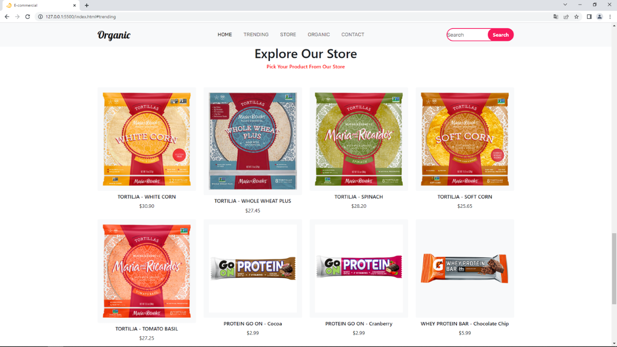

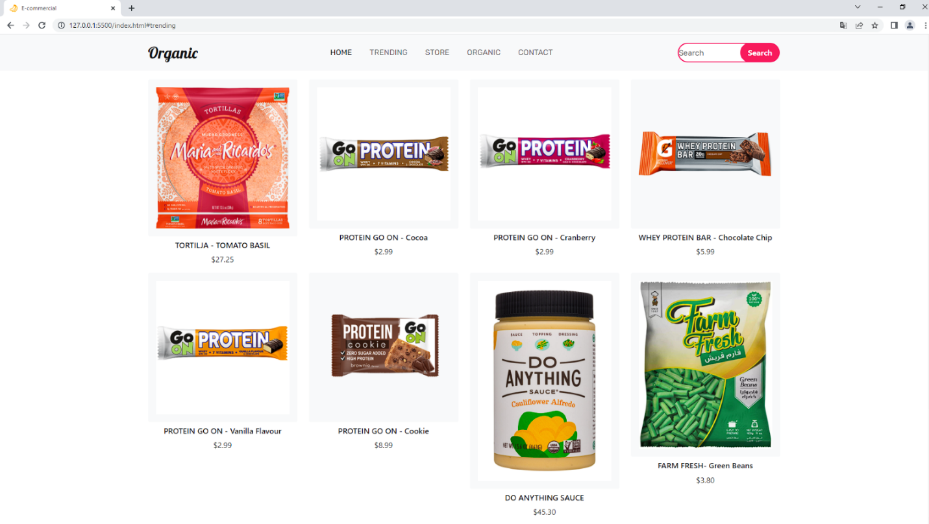

**6.9 WELCOME TO OUR HEALTH FOOD**

**Index.html**

|  |
| --- |
| <!DOCTYPE html>  <html lang="en">  <head>      <meta charset="UTF-8">      <meta http-equiv="X-UA-Compatible" content="IE=edge">      <meta name="viewport" content="width=device-width, initial-scale=1.0">        <title>E-commercial</title>      <link rel="preconnect" href="https://fonts.googleapis.com" />      <link rel="preconnect" href="https://fonts.gstatic.com" crossorigin />      <link        href="https://fonts.googleapis.com/css2?family=Lobster&family=Oswald:wght@300&family=Rubik&display=swap"        rel="stylesheet"      />      <link        href="https://cdn.jsdelivr.net/npm/bootstrap@5.0.2/dist/css/bootstrap.min.css"        rel="stylesheet"        integrity="sha384-EVSTQN3/azprG1Anm3QDgpJLIm9Nao0Yz1ztcQTwFspd3yD65VohhpuuCOmLASjC"        crossorigin="anonymous"      />      <script src="https://kit.fontawesome.com/c26cd2166c.js"></script>       <link rel="stylesheet" href="style.css" />      <link rel="icon" href="./img/banana.png" />   </head>  <body>      <nav class="navbar fixed-top navbar-expand-lg  navbar-light bg-light">          <div class="container">            <a class="navbar-brand" href="#">Organic</a>            <button              class="navbar-toggler"              type="button"              data-bs-toggle="collapse"              data-bs-target="#navbarSupportedContent"              aria-controls="navbarSupportedContent"              aria-expanded="false"              aria-label="Toggle navigation"            >              <span class="navbar-toggler-icon"></span>            </button>            <div class="collapse navbar-collapse" id="navbarSupportedContent">              <ul class="navbar-nav m-auto mb-2 mb-lg-0">                <li class="nav-item">                  <a class="nav-link active" href="#">Home</a>                </li>                <li class="nav-item">                  <a class="nav-link" href="#trending">TRENDING</a>                </li>                <li class="nav-item">                  <a class="nav-link" href="#store">Store</a>                </li>                <li class="nav-item">                  <a class="nav-link" href="#organic">Organic</a>                </li>                <li class="nav-item">                  <a class="nav-link" href="#contact">Contact</a>                </li>              </ul>              <form class="d-flex">                <input                  class="search"                  type="search"                  placeholder="Search"                  aria-label="Search"                />                <button class="btn0" type="submit">Search</button>              </form>            </div>          </div>        </nav>         <section class="main">          <div class="container py-5">            <div class="row py-5">              <div class="col-lg-7 pt-5 text-center">                <h1 class="pt-5">Nature Has Always Cared For Us!</h1>                <button class="btn1 mt-3">More Tips</button>              </div>            </div>          </div>        </section>           <section class="new">          <div class="container py-5">            <div class="row pt-5">              <div class="col-lg-7 m-auto">                <div class="row text-center">                  <div class="col-lg-4">                    <img src="./img/strawberry.png" class="img-luid" alt="" />                    <h6>NATURAL</h6>                  </div>                  <div class="col-lg-4">                    <img src="./img/grape.png" class="img-luid" alt="" />                    <h6>ORGANIC</h6>                  </div>                  <div class="col-lg-4">                    <img src="./img/apple.png" class="img-luid" alt="" />                    <h6>HEALTH</h6>                  </div>                </div>              </div>            </div>          </div>        </section>            <section class="product " id="trending">          <div class="container py-5 ">            <div class="row py-5 ">              <div class="col-lg-5 m-auto text-center ">                <h1>What's Trending</h1>                <h6 style="color: red  ">Be Healthy Organic Food</h6>              </div>            </div>            <div class="row">              <div class="col-lg-3 text-center">                <div class="card border-0 bg-light mb-2">                  <div class="card-body">                    <img src="./img/applegeta.png" class="img-fluid" alt="" />                  </div>                </div>                <h6>Applegeta</h6>                <div class="price">$5.22 <span> $7.22</span></div>              </div>              <div class="col-lg-3 text-center">                <div class="card border-0 bg-light mb-2">                  <div class="card-body">                    <img src="./img/child_Zbar.webp" class="img-fluid" alt="" />                  </div>                </div>                <h6>Zbar</h6>                <div class="price">$15.98 <span> $21.95</span></div>              </div>              <div class="col-lg-3 text-center">                <div class="card border-0 bg-light mb-2">                  <div class="card-body">                    <img src="./img/Hope.png" class="img-fluid" alt="" />                  </div>                </div>                <h6>HOPE</h6>                <div class="price">$2.89 <span> $4.89</span></div>              </div>              <div class="col-lg-3 text-center">                <div class="card border-0 bg-light mb-2">                  <div class="card-body">                    <img src="./img/siggi's.png" class="img-fluid" alt="" />                  </div>                </div>                <h6>Siggi's</h6>                <div class="price">$1.80 <span> $2</span></div>              </div>            </div>            <div class="row">              <div class="col-lg-6 text-center m-auto mt-5">                <button class="btn1">Click For More</button>              </div>            </div>          </div>        </section>            <section class="about ">          <div class="container py-5">            <div class="row py-5">              <div class="col-lg-8 m-auto text-center">                <h1>Welcome to our Organic Food Sociaty</h1>                <h6 style="color: red">Be Healthy Organic Food</h6>              </div>            </div>            <div class="row">              <div class="col-lg-4">                <img src="./img/woman_food.webp" class="img-fluid mb-3" alt="" />                <h5>BEAT MALNUTRITION AND                  NONCOMMUNICABLE DISEASES</h5>                <p>                  A healthy diet helps protect against                  malnutrition in all its forms, as well                  as diet-related noncommunicable                  diseases, including diabetes, heart                  disease, stroke and cancer                </p>              </div>              <div class="col-lg-4">                <img src="./img/woman_food2.png" class="img-fluid mb-3" alt="" />                <h5>GLOBAL RISKS</h5>                <p>                  Unhealthy diet and lack of physical                  activity are leading global risks to                  health.                </p>              </div>              <div class="col-lg-4">                <img src="./img/woman_food3.jpg" class="img-fluid mb-3" alt="" />                <h5>START EARLY IN LIFE</h5>                <p>                  Healthy dietary practices start early                  in life - breastfeeding fosters healthy                  growth and improves cognitive                  development, and may have longerterm health benefits like reducing the                  risk of becoming overweight or obese                  and developing noncommunicable                  diseases later in life.                </p>              </div>            </div>            <div class="row pt-3">              <div class="col-lg-6 text-center m-auto">                <button class="btn1">Shop More</button>              </div>            </div>          </div>        </section>      <section class="shop " id="store">          <div class="container">              <div class="row py-5">                  <div class="col-lg-8 m-auto text-center">                    <h1>Explore Our Store</h1>                    <h6 style="color: red">Pick Your Product From Our Store</h6>                  </div>          </div>          <div class="row">              <div class="col-lg-3 text-center">                <div class="card border-0 bg-light mb-2">                  <div class="card-body">                    <img src="./img/tortilja1.png" class="img-fluid" alt="" />                  </div>                </div>                <h6>TORTILJA - WHITE CORN</h6>                <p>$30.90</p>              </div>              <div class="col-lg-3 text-center">                <div class="card border-0 bg-light mb-2">                  <div class="card-body">                    <img src="./img/tortilja2.webp" class="img-fluid" alt="" />                  </div>                </div>                <h6>TORTILJA - WHOLE WHEAT PLUS</h6>                <p>$27.45</p>              </div>              <div class="col-lg-3 text-center">                <div class="card border-0 bg-light mb-2">                  <div class="card-body">                    <img src="./img/tortilja3.png" class="img-fluid" alt="" />                  </div>                </div>                <h6>TORTILJA - SPINACH</h6>                <p>$28.20</p>              </div>              <div class="col-lg-3 text-center">                <div class="card border-0 bg-light mb-2">                  <div class="card-body">                    <img src="./img/tortilja4.png" class="img-fluid" alt="" />                  </div>                </div>                <h6>TORTILJA - SOFT CORN</h6>                <p>$25.65</p>              </div>              <div class="col-lg-3 text-center">                  <div class="card border-0 bg-light mb-2">                    <div class="card-body">                      <img src="./img/tortilja5.png" class="img-fluid" alt="" />                    </div>                  </div>                  <h6>TORTILJA - TOMATO BASIL</h6>                  <p>$27.25</p>                </div>                <div class="col-lg-3 text-center">                  <div class="card border-0 bg-light mb-2">                    <div class="card-body">                      <img src="./img/protein1.png" class="img-fluid" alt="" />                    </div>                  </div>                  <h6>PROTEIN GO ON - Cocoa</h6>                  <p>$2.99</p>                </div>                <div class="col-lg-3 text-center">                  <div class="card border-0 bg-light mb-2">                    <div class="card-body">                      <img src="./img/protein2.jpg" class="img-fluid" alt="" />                    </div>                  </div>                  <h6>PROTEIN GO ON - Cranberry</h6>                  <p>$2.99</p>                </div>                <div class="col-lg-3 text-center">                  <div class="card border-0 bg-light mb-2">                    <div class="card-body">                      <img src="./img/protein3.png" class="img-fluid" alt="" />                    </div>                  </div>                  <h6>WHEY PROTEIN BAR - Chocolate Chip</h6>                  <p>$5.99</p>                </div>                <div class="col-lg-3 text-center">                  <div class="card border-0 bg-light mb-2">                    <div class="card-body">                      <img src="./img/protein4.png" class="img-fluid" alt="" />                    </div>                  </div>                  <h6>PROTEIN GO ON - Vanilla Flavour</h6>                  <p>$2.99</p>                </div>                <div class="col-lg-3 text-center">                  <div class="card border-0 bg-light mb-2">                    <div class="card-body">                      <img src="./img/protein_cookie.png" class="img-fluid" alt="" />                    </div>                  </div>                  <h6>PROTEIN GO ON - Cookie</h6>                  <p>$8.99</p>                </div>                <div class="col-lg-3 text-center">                  <div class="card border-0 bg-light mb-2">                    <div class="card-body">                      <img src="./img/Do_Anything_Sauce.jpg" class="img-fluid" alt="" />                    </div>                  </div>                  <h6>DO ANYTHING SAUCE</h6>                  <p>$45.30</p>                </div>                <div class="col-lg-3 text-center">                  <div class="card border-0 bg-light mb-2">                    <div class="card-body">                      <img src="./img/beans.webp" class="img-fluid" alt="" />                    </div>                  </div>                  <h6>FARM FRESH- Green Beans</h6>                  <p>$3.80</p>                </div>            </div>        </section>      **<section class="apple py-5  " id="organic">**  **<div class="container text-white py-5 ">**  **<div class="row py-5">**  **<div class="col-lg-8 m-auto text-center ">**  **<h1 class="font-weight-bold py-3 text">Unlock Your Potential With Good Neutrino</h1>**  **<h6 style="color: red; ">Be Healthy Organic Food</h6>**  **<button class="btn1 mt-3 ">More From Us</button>**  **</div>**  **</div>**  **</div>**  **</section>**  </body>  </html> |

**Style.css**

|  |
| --- |
| * {      padding: 0;      margin: 0;      box-sizing: border-box;    }      .navbar-brand {      font-size: 2rem;      color: black;      font-family: "Lobster", cursive;    }      .navbar-brand:hover {      color: black;    }      .nav-link {      margin-right: 10px;      margin-left: 10px;      color: black;      font-family: "Rubik", sans-serif;      text-transform: uppercase;    }      .nav-link:hover {      color: black;    }      .search {      height: 40px;      width: 80%;      border-radius: 60px;      outline: none;      margin-right: -35px;      font-family: "Rubik", sans-serif;      border: 2px solid rgb(248, 26, 92);    }      .btn0 {      height: 40px;      width: 40%;      outline: none;      border: none;      background: rgb(248, 26, 92);      color: white;      border-radius: 60px;      font-weight: 700;    }     .main {      background: url(./img/bg1.jpg) no-repeat;      background-size: cover;      height: 100vh;      background-position: 50% 50%;      width: 100%;    }      .main h1 {      font-size: 4rem;      font-weight: 700;    }      .btn1 {      height: 45px;      width: 35%;      border: none;      outline: none;      background-color: rgb(248, 26, 92);      color: white;      font-weight: 700;      border-radius: 60px;    }      .btn1:hover {      background-color: rgb(223, 15, 77);      transition: 0.5s;    }      h1 {      **font-weight**: **700px**;    }      **.card:hover** {      box-shadow: **-2px** **-1px** **25px** **-4px** rgba(**0**, **0**, **0**, **0**.**75**);      -webkit-box-shadow: **-2px** **-1px** **25px** **-4px** rgba(**0**, **0**, **0**, **0**.**75**);      -moz-box-shadow: **-2px** **-1px** **25px** **-4px** rgba(**0**, **0**, **0**, **0**.**75**);      transition: **0.5s**;    }      .price span{      text-decoration: line-through;    }    **.apple {**  **background: url(./img/fbg2.jpg) no-repeat;**  **background-size: cover;**  **height: 88vh;**  **width: 100%;**  **}**    **.text {**  **display: flex;**  **flex-direction: column;**  **justify-content: end;**  **height: 29vh;**  **text-shadow: 2px 3px rgba(0, 0, 0, 0.75);**  **font-family: "Lobster", cursive;**  **}** |

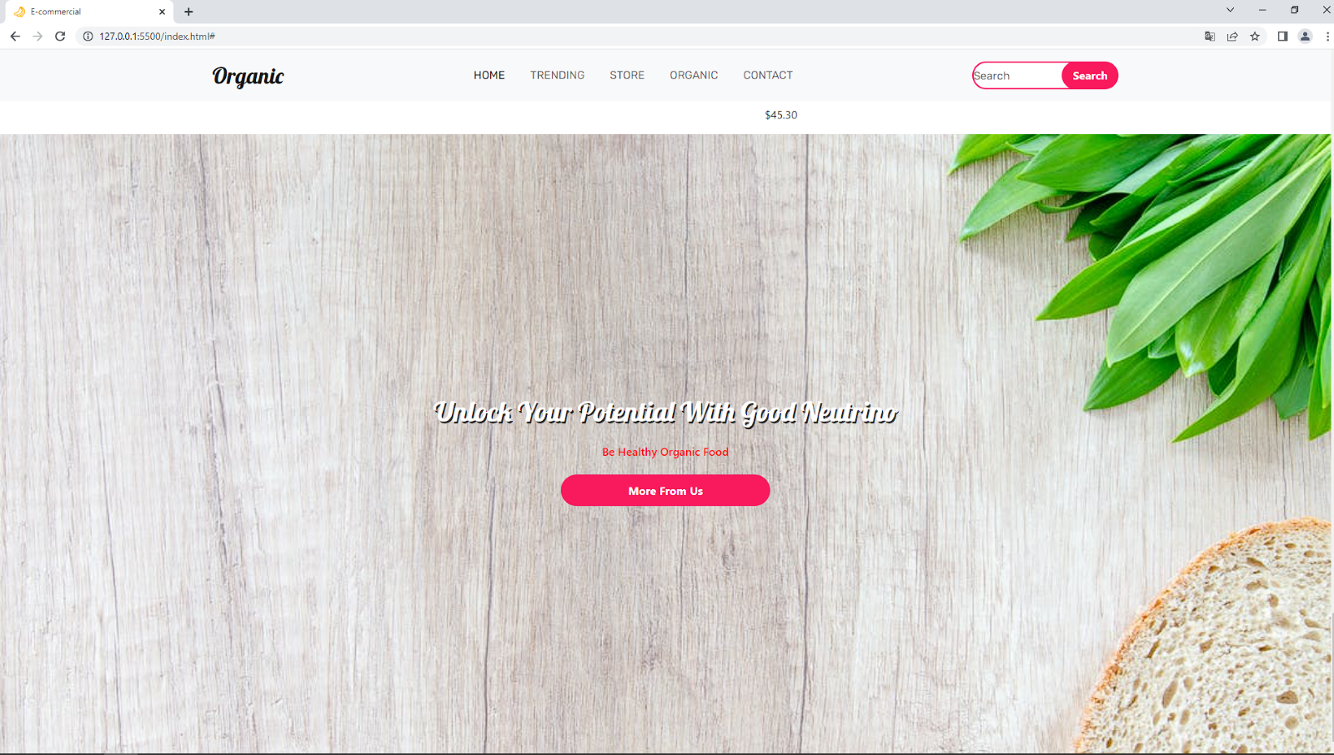 *Display:flex*  nam omogućava da pozicioniramo element na odredjen način. Na primer tako smo ovaj *Unlock your potential with good neutrion* Stavili na centar zbog:

align-items:center (centrira po vertikali)

justify-items:center (centrira po horizontali)

**6.10 CONTACT US**

**Index.html**

|  |
| --- |
| <!DOCTYPE html>  <html lang="en">  <head>      <meta charset="UTF-8">      <meta http-equiv="X-UA-Compatible" content="IE=edge">      <meta name="viewport" content="width=device-width, initial-scale=1.0">        <title>E-commercial</title>      <link rel="preconnect" href="https://fonts.googleapis.com" />      <link rel="preconnect" href="https://fonts.gstatic.com" crossorigin />      <link        href="https://fonts.googleapis.com/css2?family=Lobster&family=Oswald:wght@300&family=Rubik&display=swap"        rel="stylesheet"      />      <link        href="https://cdn.jsdelivr.net/npm/bootstrap@5.0.2/dist/css/bootstrap.min.css"        rel="stylesheet"        integrity="sha384-EVSTQN3/azprG1Anm3QDgpJLIm9Nao0Yz1ztcQTwFspd3yD65VohhpuuCOmLASjC"        crossorigin="anonymous"      />      <script src="https://kit.fontawesome.com/c26cd2166c.js"></script>       <link rel="stylesheet" href="style.css" />      <link rel="icon" href="./img/banana.png" />   </head>  <body>      <nav class="navbar fixed-top navbar-expand-lg  navbar-light bg-light">          <div class="container">            <a class="navbar-brand" href="#">Organic</a>            <button              class="navbar-toggler"              type="button"              data-bs-toggle="collapse"              data-bs-target="#navbarSupportedContent"              aria-controls="navbarSupportedContent"              aria-expanded="false"              aria-label="Toggle navigation"            >              <span class="navbar-toggler-icon"></span>            </button>            <div class="collapse navbar-collapse" id="navbarSupportedContent">              <ul class="navbar-nav m-auto mb-2 mb-lg-0">                <li class="nav-item">                  <a class="nav-link active" href="#">Home</a>                </li>                <li class="nav-item">                  <a class="nav-link" href="#trending">TRENDING</a>                </li>                <li class="nav-item">                  <a class="nav-link" href="#store">Store</a>                </li>                <li class="nav-item">                  <a class="nav-link" href="#organic">Organic</a>                </li>                <li class="nav-item">                  <a class="nav-link" href="#contact">Contact</a>                </li>              </ul>              <form class="d-flex">                <input                  class="search"                  type="search"                  placeholder="Search"                  aria-label="Search"                />                <button class="btn0" type="submit">Search</button>              </form>            </div>          </div>        </nav>         <section class="main">          <div class="container py-5">            <div class="row py-5">              <div class="col-lg-7 pt-5 text-center">                <h1 class="pt-5">Nature Has Always Cared For Us!</h1>                <button class="btn1 mt-3">More Tips</button>              </div>            </div>          </div>        </section>           <section class="new">          <div class="container py-5">            <div class="row pt-5">              <div class="col-lg-7 m-auto">                <div class="row text-center">                  <div class="col-lg-4">                    <img src="./img/strawberry.png" class="img-luid" alt="" />                    <h6>NATURAL</h6>                  </div>                  <div class="col-lg-4">                    <img src="./img/grape.png" class="img-luid" alt="" />                    <h6>ORGANIC</h6>                  </div>                  <div class="col-lg-4">                    <img src="./img/apple.png" class="img-luid" alt="" />                    <h6>HEALTH</h6>                  </div>                </div>              </div>            </div>          </div>        </section>            <section class="product " id="trending">          <div class="container py-5 ">            <div class="row py-5 ">              <div class="col-lg-5 m-auto text-center ">                <h1>What's Trending</h1>                <h6 style="color: red  ">Be Healthy Organic Food</h6>              </div>            </div>            <div class="row">              <div class="col-lg-3 text-center">                <div class="card border-0 bg-light mb-2">                  <div class="card-body">                    <img src="./img/applegeta.png" class="img-fluid" alt="" />                  </div>                </div>                <h6>Applegeta</h6>                <div class="price">$5.22 <span> $7.22</span></div>              </div>              <div class="col-lg-3 text-center">                <div class="card border-0 bg-light mb-2">                  <div class="card-body">                    <img src="./img/child_Zbar.webp" class="img-fluid" alt="" />                  </div>                </div>                <h6>Zbar</h6>                <div class="price">$15.98 <span> $21.95</span></div>              </div>              <div class="col-lg-3 text-center">                <div class="card border-0 bg-light mb-2">                  <div class="card-body">                    <img src="./img/Hope.png" class="img-fluid" alt="" />                  </div>                </div>                <h6>HOPE</h6>                <div class="price">$2.89 <span> $4.89</span></div>              </div>              <div class="col-lg-3 text-center">                <div class="card border-0 bg-light mb-2">                  <div class="card-body">                    <img src="./img/siggi's.png" class="img-fluid" alt="" />                  </div>                </div>                <h6>Siggi's</h6>                <div class="price">$1.80 <span> $2</span></div>              </div>            </div>            <div class="row">              <div class="col-lg-6 text-center m-auto mt-5">                <button class="btn1">Click For More</button>              </div>            </div>          </div>        </section>            <section class="about ">          <div class="container py-5">            <div class="row py-5">              <div class="col-lg-8 m-auto text-center">                <h1>Welcome to our Organic Food Sociaty</h1>                <h6 style="color: red">Be Healthy Organic Food</h6>              </div>            </div>            <div class="row">              <div class="col-lg-4">                <img src="./img/woman_food.webp" class="img-fluid mb-3" alt="" />                <h5>BEAT MALNUTRITION AND                  NONCOMMUNICABLE DISEASES</h5>                <p>                  A healthy diet helps protect against                  malnutrition in all its forms, as well                  as diet-related noncommunicable                  diseases, including diabetes, heart                  disease, stroke and cancer                </p>              </div>              <div class="col-lg-4">                <img src="./img/woman_food2.png" class="img-fluid mb-3" alt="" />                <h5>GLOBAL RISKS</h5>                <p>                  Unhealthy diet and lack of physical                  activity are leading global risks to                  health.                </p>              </div>              <div class="col-lg-4">                <img src="./img/woman_food3.jpg" class="img-fluid mb-3" alt="" />                <h5>START EARLY IN LIFE</h5>                <p>                  Healthy dietary practices start early                  in life - breastfeeding fosters healthy                  growth and improves cognitive                  development, and may have longerterm health benefits like reducing the                  risk of becoming overweight or obese                  and developing noncommunicable                  diseases later in life.                </p>              </div>            </div>            <div class="row pt-3">              <div class="col-lg-6 text-center m-auto">                <button class="btn1">Shop More</button>              </div>            </div>          </div>        </section>      <section class="shop " id="store">          <div class="container">              <div class="row py-5">                  <div class="col-lg-8 m-auto text-center">                    <h1>Explore Our Store</h1>                    <h6 style="color: red">Pick Your Product From Our Store</h6>                  </div>          </div>          <div class="row">              <div class="col-lg-3 text-center">                <div class="card border-0 bg-light mb-2">                  <div class="card-body">                    <img src="./img/tortilja1.png" class="img-fluid" alt="" />                  </div>                </div>                <h6>TORTILJA - WHITE CORN</h6>                <p>$30.90</p>              </div>              <div class="col-lg-3 text-center">                <div class="card border-0 bg-light mb-2">                  <div class="card-body">                    <img src="./img/tortilja2.webp" class="img-fluid" alt="" />                  </div>                </div>                <h6>TORTILJA - WHOLE WHEAT PLUS</h6>                <p>$27.45</p>              </div>              <div class="col-lg-3 text-center">                <div class="card border-0 bg-light mb-2">                  <div class="card-body">                    <img src="./img/tortilja3.png" class="img-fluid" alt="" />                  </div>                </div>                <h6>TORTILJA - SPINACH</h6>                <p>$28.20</p>              </div>              <div class="col-lg-3 text-center">                <div class="card border-0 bg-light mb-2">                  <div class="card-body">                    <img src="./img/tortilja4.png" class="img-fluid" alt="" />                  </div>                </div>                <h6>TORTILJA - SOFT CORN</h6>                <p>$25.65</p>              </div>              <div class="col-lg-3 text-center">                  <div class="card border-0 bg-light mb-2">                    <div class="card-body">                      <img src="./img/tortilja5.png" class="img-fluid" alt="" />                    </div>                  </div>                  <h6>TORTILJA - TOMATO BASIL</h6>                  <p>$27.25</p>                </div>                <div class="col-lg-3 text-center">                  <div class="card border-0 bg-light mb-2">                    <div class="card-body">                      <img src="./img/protein1.png" class="img-fluid" alt="" />                    </div>                  </div>                  <h6>PROTEIN GO ON - Cocoa</h6>                  <p>$2.99</p>                </div>                <div class="col-lg-3 text-center">                  <div class="card border-0 bg-light mb-2">                    <div class="card-body">                      <img src="./img/protein2.jpg" class="img-fluid" alt="" />                    </div>                  </div>                  <h6>PROTEIN GO ON - Cranberry</h6>                  <p>$2.99</p>                </div>                <div class="col-lg-3 text-center">                  <div class="card border-0 bg-light mb-2">                    <div class="card-body">                      <img src="./img/protein3.png" class="img-fluid" alt="" />                    </div>                  </div>                  <h6>WHEY PROTEIN BAR - Chocolate Chip</h6>                  <p>$5.99</p>                </div>                <div class="col-lg-3 text-center">                  <div class="card border-0 bg-light mb-2">                    <div class="card-body">                      <img src="./img/protein4.png" class="img-fluid" alt="" />                    </div>                  </div>                  <h6>PROTEIN GO ON - Vanilla Flavour</h6>                  <p>$2.99</p>                </div>                <div class="col-lg-3 text-center">                  <div class="card border-0 bg-light mb-2">                    <div class="card-body">                      <img src="./img/protein_cookie.png" class="img-fluid" alt="" />                    </div>                  </div>                  <h6>PROTEIN GO ON - Cookie</h6>                  <p>$8.99</p>                </div>                <div class="col-lg-3 text-center">                  <div class="card border-0 bg-light mb-2">                    <div class="card-body">                      <img src="./img/Do_Anything_Sauce.jpg" class="img-fluid" alt="" />                    </div>                  </div>                  <h6>DO ANYTHING SAUCE</h6>                  <p>$45.30</p>                </div>                <div class="col-lg-3 text-center">                  <div class="card border-0 bg-light mb-2">                    <div class="card-body">                      <img src="./img/beans.webp" class="img-fluid" alt="" />                    </div>                  </div>                  <h6>FARM FRESH- Green Beans</h6>                  <p>$3.80</p>                </div>            </div>        </section>      <section class="apple py-5  " id="organic">      <div class="container text-white py-5 ">          <div class="row py-5">              <div class="col-lg-8 m-auto text-center ">                  <h1 class="font-weight-bold py-3 text">Unlock Your Potential With Good Neutrino</h1>                  <h6 style="color: red; ">Be Healthy Organic Food</h6>                  <button class="btn1 mt-3 ">More From Us</button>              </div>          </div>      </div>  </section>    **<section class="contact py-5 " id="contact">**  **<div class="container py-5">**  **<div class="row">**  **<div class="col-lg-5 m-auto text-center">**  **<h1>Contact Us </h1>**  **<h6 style="color: red;">Always Be In Touch With Us</h6>**  **</div>**  **</div>**  **<div class="row py-5">**  **<div class="col-lg-9 m-auto ">**  **<div class="row">**  **<div class="col-lg-4">**  **<h6>LOCATION</h6>**  **<p>New York 0911 First Street DC</p>**    **<h6>PHONE</h6>**  **<p>03444-24359555</p>**    **<h6>EMAIL</h6>**  **<p>rezwanjhony@gmail.com</p>**    **</div>**  **<div class="col-lg-7">**  **<div class="row">**  **<div class="col-lg-6">**  **<input type="text" class="form-control bg-light" placeholder="First Name">**  **</div>**  **<div class="col-lg-6">**  **<input type="text" class="form-control bg-light" placeholder="Last Name">**  **</div>**  **</div>**  **<div class="row">**  **<div class="col-lg-12 py-3">**  **<textarea name=""  placeholder="Enter Your Name"class="form-control bg-light" id="" cols="10" rows="5"></textarea>**  **</div>**  **</div>**  **<button class="btn1">Submit</button>**  **</div>**  **</div>**  **</div>**  **</div>**  **</section>**  </body>  </html> |

**Style.css**

|  |
| --- |
| * {      padding: 0;      margin: 0;      box-sizing: border-box;    }      .navbar-brand {      font-size: 2rem;      color: black;      font-family: "Lobster", cursive;    }      .navbar-brand:hover {      color: black;    }      .nav-link {      margin-right: 10px;      margin-left: 10px;      color: black;      font-family: "Rubik", sans-serif;      text-transform: uppercase;    }      .nav-link:hover {      color: black;    }      .search {      height: 40px;      width: 80%;      border-radius: 60px;      outline: none;      margin-right: -35px;      font-family: "Rubik", sans-serif;      border: 2px solid rgb(248, 26, 92);    }      .btn0 {      height: 40px;      width: 40%;      outline: none;      border: none;      background: rgb(248, 26, 92);      color: white;      border-radius: 60px;      font-weight: 700;    }     .main {      background: url(./img/bg1.jpg) no-repeat;      background-size: cover;      height: 100vh;      background-position: 50% 50%;      width: 100%;    }      .main h1 {      font-size: 4rem;      font-weight: 700;    }      .btn1 {      height: 45px;      width: 35%;      border: none;      outline: none;      background-color: rgb(248, 26, 92);      color: white;      font-weight: 700;      border-radius: 60px;    }      .btn1:hover {      background-color: rgb(223, 15, 77);      transition: 0.5s;    }      h1 {      **font-weight**: **700px**;    }      **.card:hover** {      box-shadow: **-2px** **-1px** **25px** **-4px** rgba(**0**, **0**, **0**, **0**.**75**);      -webkit-box-shadow: **-2px** **-1px** **25px** **-4px** rgba(**0**, **0**, **0**, **0**.**75**);      -moz-box-shadow: **-2px** **-1px** **25px** **-4px** rgba(**0**, **0**, **0**, **0**.**75**);      transition: **0.5s**;    }      .price span{      text-decoration: line-through;    }     .apple {      background: url(./img/fbg2.jpg) no-repeat;      background-size: cover;      height: 88vh;      width: 100%;    }        .text {      display: flex;      flex-direction: column;      justify-content: end;      height: 29vh;      text-shadow: 2px 3px rgba(0, 0, 0, 0.75);      font-family: "Lobster", cursive;    } |

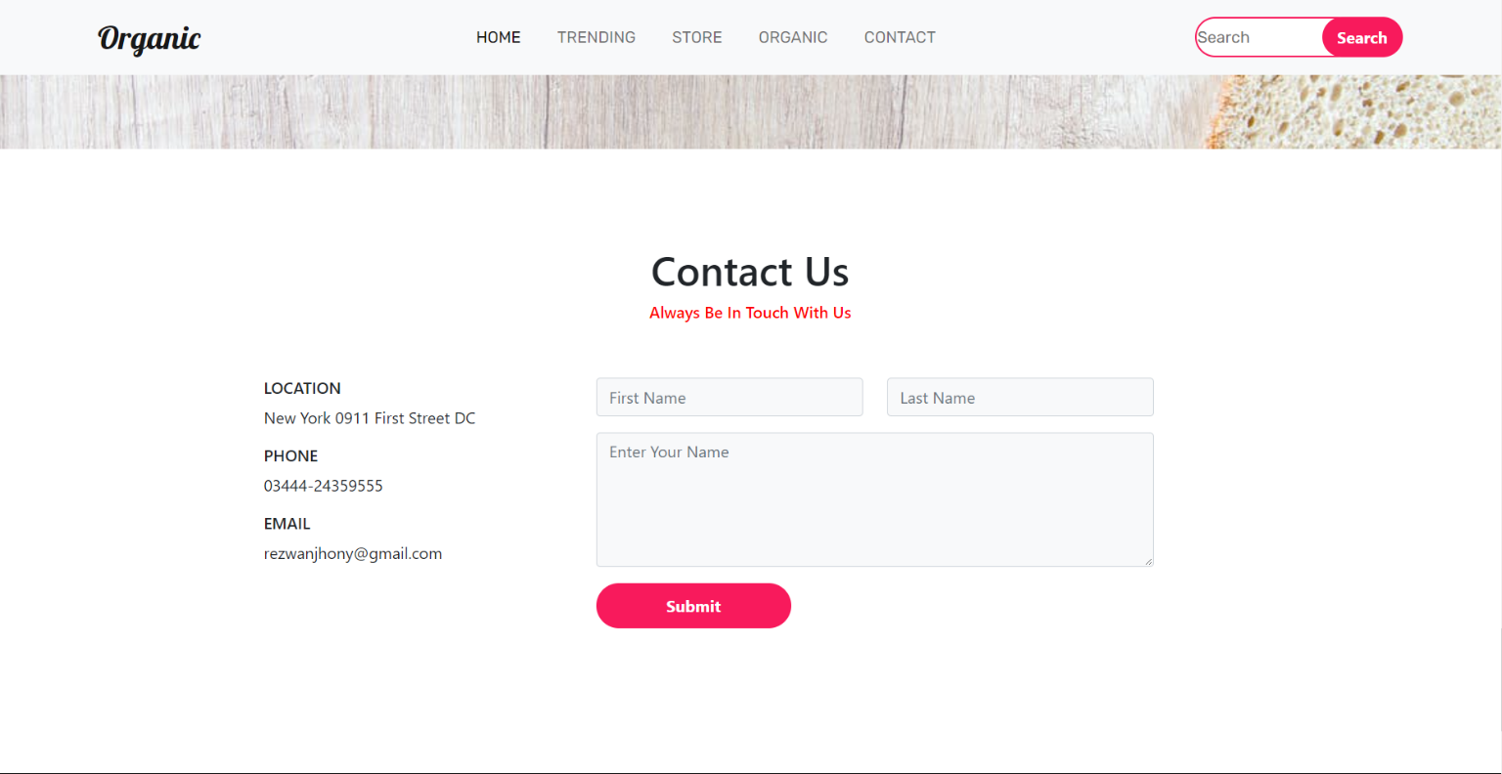

**6.11 FOOTER**

Index.html

|  |
| --- |
| <!DOCTYPE html>  <html lang="en">  <head>      <meta charset="UTF-8">      <meta http-equiv="X-UA-Compatible" content="IE=edge">      <meta name="viewport" content="width=device-width, initial-scale=1.0">        <title>E-commercial</title>      <link rel="preconnect" href="https://fonts.googleapis.com" />      <link rel="preconnect" href="https://fonts.gstatic.com" crossorigin />      <link        href="https://fonts.googleapis.com/css2?family=Lobster&family=Oswald:wght@300&family=Rubik&display=swap"        rel="stylesheet"      />      <link        href="https://cdn.jsdelivr.net/npm/bootstrap@5.0.2/dist/css/bootstrap.min.css"        rel="stylesheet"        integrity="sha384-EVSTQN3/azprG1Anm3QDgpJLIm9Nao0Yz1ztcQTwFspd3yD65VohhpuuCOmLASjC"        crossorigin="anonymous"      />      <script src="https://kit.fontawesome.com/c26cd2166c.js"></script>       <link rel="stylesheet" href="style.css" />      <link rel="icon" href="./img/banana.png" />   </head>  <body>      <nav class="navbar fixed-top navbar-expand-lg  navbar-light bg-light">          <div class="container">            <a class="navbar-brand" href="#">Organic</a>            <button              class="navbar-toggler"              type="button"              data-bs-toggle="collapse"              data-bs-target="#navbarSupportedContent"              aria-controls="navbarSupportedContent"              aria-expanded="false"              aria-label="Toggle navigation"            >              <span class="navbar-toggler-icon"></span>            </button>            <div class="collapse navbar-collapse" id="navbarSupportedContent">              <ul class="navbar-nav m-auto mb-2 mb-lg-0">                <li class="nav-item">                  <a class="nav-link active" href="#">Home</a>                </li>                <li class="nav-item">                  <a class="nav-link" href="#trending">TRENDING</a>                </li>                <li class="nav-item">                  <a class="nav-link" href="#store">Store</a>                </li>                <li class="nav-item">                  <a class="nav-link" href="#organic">Organic</a>                </li>                <li class="nav-item">                  <a class="nav-link" href="#contact">Contact</a>                </li>              </ul>              <form class="d-flex">                <input                  class="search"                  type="search"                  placeholder="Search"                  aria-label="Search"                />                <button class="btn0" type="submit">Search</button>              </form>            </div>          </div>        </nav>         <section class="main">          <div class="container py-5">            <div class="row py-5">              <div class="col-lg-7 pt-5 text-center">                <h1 class="pt-5">Nature Has Always Cared For Us!</h1>                <button class="btn1 mt-3">More Tips</button>              </div>            </div>          </div>        </section>           <section class="new">          <div class="container py-5">            <div class="row pt-5">              <div class="col-lg-7 m-auto">                <div class="row text-center">                  <div class="col-lg-4">                    <img src="./img/strawberry.png" class="img-luid" alt="" />                    <h6>NATURAL</h6>                  </div>                  <div class="col-lg-4">                    <img src="./img/grape.png" class="img-luid" alt="" />                    <h6>ORGANIC</h6>                  </div>                  <div class="col-lg-4">                    <img src="./img/apple.png" class="img-luid" alt="" />                    <h6>HEALTH</h6>                  </div>                </div>              </div>            </div>          </div>        </section>            <section class="product " id="trending">          <div class="container py-5 ">            <div class="row py-5 ">              <div class="col-lg-5 m-auto text-center ">                <h1>What's Trending</h1>                <h6 style="color: red  ">Be Healthy Organic Food</h6>              </div>            </div>            <div class="row">              <div class="col-lg-3 text-center">                <div class="card border-0 bg-light mb-2">                  <div class="card-body">                    <img src="./img/applegeta.png" class="img-fluid" alt="" />                  </div>                </div>                <h6>Applegeta</h6>                <div class="price">$5.22 <span> $7.22</span></div>              </div>              <div class="col-lg-3 text-center">                <div class="card border-0 bg-light mb-2">                  <div class="card-body">                    <img src="./img/child_Zbar.webp" class="img-fluid" alt="" />                  </div>                </div>                <h6>Zbar</h6>                <div class="price">$15.98 <span> $21.95</span></div>              </div>              <div class="col-lg-3 text-center">                <div class="card border-0 bg-light mb-2">                  <div class="card-body">                    <img src="./img/Hope.png" class="img-fluid" alt="" />                  </div>                </div>                <h6>HOPE</h6>                <div class="price">$2.89 <span> $4.89</span></div>              </div>              <div class="col-lg-3 text-center">                <div class="card border-0 bg-light mb-2">                  <div class="card-body">                    <img src="./img/siggi's.png" class="img-fluid" alt="" />                  </div>                </div>                <h6>Siggi's</h6>                <div class="price">$1.80 <span> $2</span></div>              </div>            </div>            <div class="row">              <div class="col-lg-6 text-center m-auto mt-5">                <button class="btn1">Click For More</button>              </div>            </div>          </div>        </section>            <section class="about ">          <div class="container py-5">            <div class="row py-5">              <div class="col-lg-8 m-auto text-center">                <h1>Welcome to our Organic Food Sociaty</h1>                <h6 style="color: red">Be Healthy Organic Food</h6>              </div>            </div>            <div class="row">              <div class="col-lg-4">                <img src="./img/woman_food.webp" class="img-fluid mb-3" alt="" />                <h5>BEAT MALNUTRITION AND                  NONCOMMUNICABLE DISEASES</h5>                <p>                  A healthy diet helps protect against                  malnutrition in all its forms, as well                  as diet-related noncommunicable                  diseases, including diabetes, heart                  disease, stroke and cancer                </p>              </div>              <div class="col-lg-4">                <img src="./img/woman_food2.png" class="img-fluid mb-3" alt="" />                <h5>GLOBAL RISKS</h5>                <p>                  Unhealthy diet and lack of physical                  activity are leading global risks to                  health.                </p>              </div>              <div class="col-lg-4">                <img src="./img/woman_food3.jpg" class="img-fluid mb-3" alt="" />                <h5>START EARLY IN LIFE</h5>                <p>                  Healthy dietary practices start early                  in life - breastfeeding fosters healthy                  growth and improves cognitive                  development, and may have longerterm health benefits like reducing the                  risk of becoming overweight or obese                  and developing noncommunicable                  diseases later in life.                </p>              </div>            </div>            <div class="row pt-3">              <div class="col-lg-6 text-center m-auto">                <button class="btn1">Shop More</button>              </div>            </div>          </div>        </section>      <section class="shop " id="store">          <div class="container">              <div class="row py-5">                  <div class="col-lg-8 m-auto text-center">                    <h1>Explore Our Store</h1>                    <h6 style="color: red">Pick Your Product From Our Store</h6>                  </div>          </div>          <div class="row">              <div class="col-lg-3 text-center">                <div class="card border-0 bg-light mb-2">                  <div class="card-body">                    <img src="./img/tortilja1.png" class="img-fluid" alt="" />                  </div>                </div>                <h6>TORTILJA - WHITE CORN</h6>                <p>$30.90</p>              </div>              <div class="col-lg-3 text-center">                <div class="card border-0 bg-light mb-2">                  <div class="card-body">                    <img src="./img/tortilja2.webp" class="img-fluid" alt="" />                  </div>                </div>                <h6>TORTILJA - WHOLE WHEAT PLUS</h6>                <p>$27.45</p>              </div>              <div class="col-lg-3 text-center">                <div class="card border-0 bg-light mb-2">                  <div class="card-body">                    <img src="./img/tortilja3.png" class="img-fluid" alt="" />                  </div>                </div>                <h6>TORTILJA - SPINACH</h6>                <p>$28.20</p>              </div>              <div class="col-lg-3 text-center">                <div class="card border-0 bg-light mb-2">                  <div class="card-body">                    <img src="./img/tortilja4.png" class="img-fluid" alt="" />                  </div>                </div>                <h6>TORTILJA - SOFT CORN</h6>                <p>$25.65</p>              </div>              <div class="col-lg-3 text-center">                  <div class="card border-0 bg-light mb-2">                    <div class="card-body">                      <img src="./img/tortilja5.png" class="img-fluid" alt="" />                    </div>                  </div>                  <h6>TORTILJA - TOMATO BASIL</h6>                  <p>$27.25</p>                </div>                <div class="col-lg-3 text-center">                  <div class="card border-0 bg-light mb-2">                    <div class="card-body">                      <img src="./img/protein1.png" class="img-fluid" alt="" />                    </div>                  </div>                  <h6>PROTEIN GO ON - Cocoa</h6>                  <p>$2.99</p>                </div>                <div class="col-lg-3 text-center">                  <div class="card border-0 bg-light mb-2">                    <div class="card-body">                      <img src="./img/protein2.jpg" class="img-fluid" alt="" />                    </div>                  </div>                  <h6>PROTEIN GO ON - Cranberry</h6>                  <p>$2.99</p>                </div>                <div class="col-lg-3 text-center">                  <div class="card border-0 bg-light mb-2">                    <div class="card-body">                      <img src="./img/protein3.png" class="img-fluid" alt="" />                    </div>                  </div>                  <h6>WHEY PROTEIN BAR - Chocolate Chip</h6>                  <p>$5.99</p>                </div>                <div class="col-lg-3 text-center">                  <div class="card border-0 bg-light mb-2">                    <div class="card-body">                      <img src="./img/protein4.png" class="img-fluid" alt="" />                    </div>                  </div>                  <h6>PROTEIN GO ON - Vanilla Flavour</h6>                  <p>$2.99</p>                </div>                <div class="col-lg-3 text-center">                  <div class="card border-0 bg-light mb-2">                    <div class="card-body">                      <img src="./img/protein_cookie.png" class="img-fluid" alt="" />                    </div>                  </div>                  <h6>PROTEIN GO ON - Cookie</h6>                  <p>$8.99</p>                </div>                <div class="col-lg-3 text-center">                  <div class="card border-0 bg-light mb-2">                    <div class="card-body">                      <img src="./img/Do_Anything_Sauce.jpg" class="img-fluid" alt="" />                    </div>                  </div>                  <h6>DO ANYTHING SAUCE</h6>                  <p>$45.30</p>                </div>                <div class="col-lg-3 text-center">                  <div class="card border-0 bg-light mb-2">                    <div class="card-body">                      <img src="./img/beans.webp" class="img-fluid" alt="" />                    </div>                  </div>                  <h6>FARM FRESH- Green Beans</h6>                  <p>$3.80</p>                </div>            </div>        </section>      <section class="apple py-5  " id="organic">      <div class="container text-white py-5 ">          <div class="row py-5">              <div class="col-lg-8 m-auto text-center ">                  <h1 class="font-weight-bold py-3 text">Unlock Your Potential With Good Neutrino</h1>                  <h6 style="color: red; ">Be Healthy Organic Food</h6>                  <button class="btn1 mt-3 ">More From Us</button>              </div>          </div>      </div>  </section>    <section class="contact py-5 " id="contact">      <div class="container py-5">          <div class="row">              <div class="col-lg-5 m-auto text-center">                  <h1>Contact Us </h1>                      <h6 style="color: red;">Always Be In Touch With Us</h6>              </div>          </div>          <div class="row py-5">              <div class="col-lg-9 m-auto ">                  <div class="row">                      <div class="col-lg-4">                          <h6>LOCATION</h6>                          <p>New York 0911 First Street DC</p>                                              <h6>PHONE</h6>                          <p>03444-24359555</p>                                               <h6>EMAIL</h6>                          <p>rezwanjhony@gmail.com</p>                                       </div>                  <div class="col-lg-7">                      <div class="row">                          <div class="col-lg-6">                              <input type="text" class="form-control bg-light" placeholder="First Name">                          </div>                          <div class="col-lg-6">                              <input type="text" class="form-control bg-light" placeholder="Last Name">                          </div>                      </div>                      <div class="row">                          <div class="col-lg-12 py-3">                              <textarea name=""  placeholder="Enter Your Name"class="form-control bg-light" id="" cols="10" rows="5"></textarea>                          </div>                      </div>                      <button class="btn1">Submit</button>                  </div>              </div>          </div>      </div>  </section>    **<section class="news py-5">**  **<div class="container py-5">**  **<div class="row">**  **<div class="col-lg-9 m-auto text-center">**  **<h1>Join Our Secret Society</h1>**  **<input type="text" class="px-3" placeholder="Enter Your Email">**  **<button class="btn2 active">Submit</button>**  **</div>**  **</div>**  **<div class="row pt-5">**  **<div class="col-lg-11 m-auto">**  **<div class="row">**  **<div class="col-lg-3 py-3">**  **<h5 class="pb-3">CUSTOMER CARE</h5>**  **<p>Regular</p>**  **<p>On time</p>**  **<p>Always Care</p>**    **</div>**  **<div class="col-lg-3 py-3">**  **<h5 class="pb-3"> BRAND</h5>**  **<p>About</p>**  **<p>Services</p>**  **<p>Features</p>**    **</div>**  **<div class="col-lg-3 py-3">**  **<h5 class="pb-3">MORE</h5>**  **<p>Sipment</p>**  **<p>Warranty</p>**  **<p>Privacy & Policy</p>**    **</div>**  **<div class="col-lg-3 py-3">**  **<h5 class="pb-3">CUSTOMER CARE</h5>**  **<span><i class="fab fa-facebook"></i></span>**  **<span><i class="fab fa-instagram"></i></span>**  **<span><i class="fab fa-twitter"></i></span>**  **<span><i class="fab fa-google-plus"></i></span>**    **</div>**  **</div>**  **</div>**  **</div>**  **<hr>**  **<p class="text-center">Copyright ©2021 All rights reserved | This template is made with by Valentina Dzambic</p>**  **</div>**  **</section>**  </body>  </html> |

**Style.css**

|  |
| --- |
| * {      padding: 0;      margin: 0;      box-sizing: border-box;    }      .navbar-brand {      font-size: 2rem;      color: black;      font-family: "Lobster", cursive;    }      .navbar-brand:hover {      color: black;    }      .nav-link {      margin-right: 10px;      margin-left: 10px;      color: black;      font-family: "Rubik", sans-serif;      text-transform: uppercase;    }      .nav-link:hover {      color: black;    }      .search {      height: 40px;      width: 80%;      border-radius: 60px;      outline: none;      margin-right: -35px;      font-family: "Rubik", sans-serif;      border: 2px solid rgb(248, 26, 92);    }      .btn0 {      height: 40px;      width: 40%;      outline: none;      border: none;      background: rgb(248, 26, 92);      color: white;      border-radius: 60px;      font-weight: 700;    }     .main {      background: url(./img/bg1.jpg) no-repeat;      background-size: cover;      height: 100vh;      background-position: 50% 50%;      width: 100%;    }      .main h1 {      font-size: 4rem;      font-weight: 700;    }      .btn1 {      height: 45px;      width: 35%;      border: none;      outline: none;      background-color: rgb(248, 26, 92);      color: white;      font-weight: 700;      border-radius: 60px;    }      .btn1:hover {      background-color: rgb(223, 15, 77);      transition: 0.5s;    }      h1 {      **font-weight**: **700px**;    }      **.card:hover** {      box-shadow: **-2px** **-1px** **25px** **-4px** rgba(**0**, **0**, **0**, **0**.**75**);      -webkit-box-shadow: **-2px** **-1px** **25px** **-4px** rgba(**0**, **0**, **0**, **0**.**75**);      -moz-box-shadow: **-2px** **-1px** **25px** **-4px** rgba(**0**, **0**, **0**, **0**.**75**);      transition: **0.5s**;    }      .price span{      text-decoration: line-through;    }     .apple {      background: url(./img/fbg2.jpg) no-repeat;      background-size: cover;      height: 88vh;      width: 100%;    }        .text {      display: flex;      flex-direction: column;      justify-content: end;      height: 29vh;      text-shadow: 2px 3px rgba(0, 0, 0, 0.75);      font-family: "Lobster", cursive;    }    **.news** {      **background-color**: black;      **color**: white;    }      **.btn2** {      **height**: **45px**;      **width**: **100px**;      **background**: white;      **margin-left**: **-10px**;      **border**: **2px** **solid** white;      **font-weight**: **600**;    }        **.news** input {      **height**: **45px**;      **width**: **55**%;      **border**: **2px** **solid** white;      **outline**: **none**;      **background-color**: black;      **color**: white;      **margin-top**: **20px**;      **font-weight**: **600**;    }      **.news** p {      **margin**: **0**;    }      **.fab** {      **font-size**: **2**.**5**rem;      **cursor**: **pointer**;      **padding-right**: **5px**;    } |

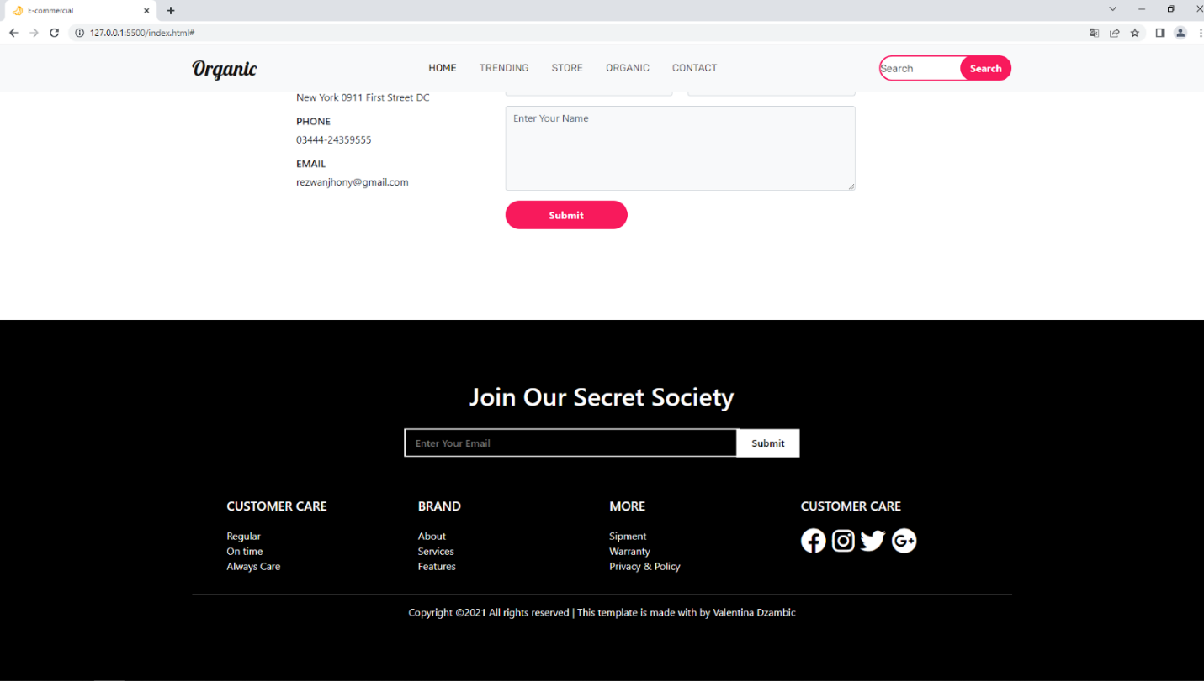

**6.12 DODAVANJE JAVASCRIPTE**

**Index.html**

|  |
| --- |
| <!DOCTYPE html>  <html lang="en">  <head>      <meta charset="UTF-8">      <meta http-equiv="X-UA-Compatible" content="IE=edge">      <meta name="viewport" content="width=device-width, initial-scale=1.0">        <title>E-commercial</title>      <link rel="preconnect" href="https://fonts.googleapis.com" />      <link rel="preconnect" href="https://fonts.gstatic.com" crossorigin />      <link        href="https://fonts.googleapis.com/css2?family=Lobster&family=Oswald:wght@300&family=Rubik&display=swap"        rel="stylesheet"      />      <link        href="https://cdn.jsdelivr.net/npm/bootstrap@5.0.2/dist/css/bootstrap.min.css"        rel="stylesheet"        integrity="sha384-EVSTQN3/azprG1Anm3QDgpJLIm9Nao0Yz1ztcQTwFspd3yD65VohhpuuCOmLASjC"        crossorigin="anonymous"      />      <script src="https://kit.fontawesome.com/c26cd2166c.js"></script>       <link rel="stylesheet" href="style.css" />      <link rel="icon" href="./img/banana.png" />   </head>  <body>      <nav class="navbar fixed-top navbar-expand-lg  navbar-light bg-light">          <div class="container">            <a class="navbar-brand" href="#">Organic</a>            <button              class="navbar-toggler"              type="button"              data-bs-toggle="collapse"              data-bs-target="#navbarSupportedContent"              aria-controls="navbarSupportedContent"              aria-expanded="false"              aria-label="Toggle navigation"            >              <span class="navbar-toggler-icon"></span>            </button>            <div class="collapse navbar-collapse" id="navbarSupportedContent">              <ul class="navbar-nav m-auto mb-2 mb-lg-0">                <li class="nav-item">                  <a class="nav-link active" href="#">Home</a>                </li>                <li class="nav-item">                  <a class="nav-link" href="#trending">TRENDING</a>                </li>                <li class="nav-item">                  <a class="nav-link" href="#store">Store</a>                </li>                <li class="nav-item">                  <a class="nav-link" href="#organic">Organic</a>                </li>                <li class="nav-item">                  <a class="nav-link" href="#contact">Contact</a>                </li>              </ul>              <form class="d-flex">                <input                  class="search"                  type="search"                  placeholder="Search"                  aria-label="Search"                />                <button class="btn0" type="submit">Search</button>              </form>            </div>          </div>        </nav>         <section class="main">          <div class="container py-5">            <div class="row py-5">              <div class="col-lg-7 pt-5 text-center">                <h1 class="pt-5">Nature Has Always Cared For Us!</h1>                <button class="btn1 mt-3">More Tips</button>              </div>            </div>          </div>        </section>           <section class="new">          <div class="container py-5">            <div class="row pt-5">              <div class="col-lg-7 m-auto">                <div class="row text-center">                  <div class="col-lg-4">                    <img src="./img/strawberry.png" class="img-luid" alt="" />                    <h6>NATURAL</h6>                  </div>                  <div class="col-lg-4">                    <img src="./img/grape.png" class="img-luid" alt="" />                    <h6>ORGANIC</h6>                  </div>                  <div class="col-lg-4">                    <img src="./img/apple.png" class="img-luid" alt="" />                    <h6>HEALTH</h6>                  </div>                </div>              </div>            </div>          </div>        </section>            <section class="product **reveal**" id="trending">          <div class="container py-5 ">            <div class="row py-5 ">              <div class="col-lg-5 m-auto text-center ">                <h1>What's Trending</h1>                <h6 style="color: red  ">Be Healthy Organic Food</h6>              </div>            </div>            <div class="row">              <div class="col-lg-3 text-center">                <div class="card border-0 bg-light mb-2">                  <div class="card-body">                    <img src="./img/applegeta.png" class="img-fluid" alt="" />                  </div>                </div>                <h6>Applegeta</h6>                <div class="price">$5.22 <span> $7.22</span></div>              </div>              <div class="col-lg-3 text-center">                <div class="card border-0 bg-light mb-2">                  <div class="card-body">                    <img src="./img/child_Zbar.webp" class="img-fluid" alt="" />                  </div>                </div>                <h6>Zbar</h6>                <div class="price">$15.98 <span> $21.95</span></div>              </div>              <div class="col-lg-3 text-center">                <div class="card border-0 bg-light mb-2">                  <div class="card-body">                    <img src="./img/Hope.png" class="img-fluid" alt="" />                  </div>                </div>                <h6>HOPE</h6>                <div class="price">$2.89 <span> $4.89</span></div>              </div>              <div class="col-lg-3 text-center">                <div class="card border-0 bg-light mb-2">                  <div class="card-body">                    <img src="./img/siggi's.png" class="img-fluid" alt="" />                  </div>                </div>                <h6>Siggi's</h6>                <div class="price">$1.80 <span> $2</span></div>              </div>            </div>            <div class="row">              <div class="col-lg-6 text-center m-auto mt-5">                <button class="btn1">Click For More</button>              </div>            </div>          </div>        </section>            <section class="about **reveal**">          <div class="container py-5">            <div class="row py-5">              <div class="col-lg-8 m-auto text-center">                <h1>Welcome to our Organic Food Sociaty</h1>                <h6 style="color: red">Be Healthy Organic Food</h6>              </div>            </div>            <div class="row">              <div class="col-lg-4">                <img src="./img/woman_food.webp" class="img-fluid mb-3" alt="" />                <h5>BEAT MALNUTRITION AND                  NONCOMMUNICABLE DISEASES</h5>                <p>                  A healthy diet helps protect against                  malnutrition in all its forms, as well                  as diet-related noncommunicable                  diseases, including diabetes, heart                  disease, stroke and cancer                </p>              </div>              <div class="col-lg-4">                <img src="./img/woman_food2.png" class="img-fluid mb-3" alt="" />                <h5>GLOBAL RISKS</h5>                <p>                  Unhealthy diet and lack of physical                  activity are leading global risks to                  health.                </p>              </div>              <div class="col-lg-4">                <img src="./img/woman_food3.jpg" class="img-fluid mb-3" alt="" />                <h5>START EARLY IN LIFE</h5>                <p>                  Healthy dietary practices start early                  in life - breastfeeding fosters healthy                  growth and improves cognitive                  development, and may have longerterm health benefits like reducing the                  risk of becoming overweight or obese                  and developing noncommunicable                  diseases later in life.                </p>              </div>            </div>            <div class="row pt-3">              <div class="col-lg-6 text-center m-auto">                <button class="btn1">Shop More</button>              </div>            </div>          </div>        </section>      <section class="shop **reveal**" id="store">          <div class="container">              <div class="row py-5">                  <div class="col-lg-8 m-auto text-center">                    <h1>Explore Our Store</h1>                    <h6 style="color: red">Pick Your Product From Our Store</h6>                  </div>          </div>          <div class="row">              <div class="col-lg-3 text-center">                <div class="card border-0 bg-light mb-2">                  <div class="card-body">                    <img src="./img/tortilja1.png" class="img-fluid" alt="" />                  </div>                </div>                <h6>TORTILJA - WHITE CORN</h6>                <p>$30.90</p>              </div>              <div class="col-lg-3 text-center">                <div class="card border-0 bg-light mb-2">                  <div class="card-body">                    <img src="./img/tortilja2.webp" class="img-fluid" alt="" />                  </div>                </div>                <h6>TORTILJA - WHOLE WHEAT PLUS</h6>                <p>$27.45</p>              </div>              <div class="col-lg-3 text-center">                <div class="card border-0 bg-light mb-2">                  <div class="card-body">                    <img src="./img/tortilja3.png" class="img-fluid" alt="" />                  </div>                </div>                <h6>TORTILJA - SPINACH</h6>                <p>$28.20</p>              </div>              <div class="col-lg-3 text-center">                <div class="card border-0 bg-light mb-2">                  <div class="card-body">                    <img src="./img/tortilja4.png" class="img-fluid" alt="" />                  </div>                </div>                <h6>TORTILJA - SOFT CORN</h6>                <p>$25.65</p>              </div>              <div class="col-lg-3 text-center">                  <div class="card border-0 bg-light mb-2">                    <div class="card-body">                      <img src="./img/tortilja5.png" class="img-fluid" alt="" />                    </div>                  </div>                  <h6>TORTILJA - TOMATO BASIL</h6>                  <p>$27.25</p>                </div>                <div class="col-lg-3 text-center">                  <div class="card border-0 bg-light mb-2">                    <div class="card-body">                      <img src="./img/protein1.png" class="img-fluid" alt="" />                    </div>                  </div>                  <h6>PROTEIN GO ON - Cocoa</h6>                  <p>$2.99</p>                </div>                <div class="col-lg-3 text-center">                  <div class="card border-0 bg-light mb-2">                    <div class="card-body">                      <img src="./img/protein2.jpg" class="img-fluid" alt="" />                    </div>                  </div>                  <h6>PROTEIN GO ON - Cranberry</h6>                  <p>$2.99</p>                </div>                <div class="col-lg-3 text-center">                  <div class="card border-0 bg-light mb-2">                    <div class="card-body">                      <img src="./img/protein3.png" class="img-fluid" alt="" />                    </div>                  </div>                  <h6>WHEY PROTEIN BAR - Chocolate Chip</h6>                  <p>$5.99</p>                </div>                <div class="col-lg-3 text-center">                  <div class="card border-0 bg-light mb-2">                    <div class="card-body">                      <img src="./img/protein4.png" class="img-fluid" alt="" />                    </div>                  </div>                  <h6>PROTEIN GO ON - Vanilla Flavour</h6>                  <p>$2.99</p>                </div>                <div class="col-lg-3 text-center">                  <div class="card border-0 bg-light mb-2">                    <div class="card-body">                      <img src="./img/protein_cookie.png" class="img-fluid" alt="" />                    </div>                  </div>                  <h6>PROTEIN GO ON - Cookie</h6>                  <p>$8.99</p>                </div>                <div class="col-lg-3 text-center">                  <div class="card border-0 bg-light mb-2">                    <div class="card-body">                      <img src="./img/Do_Anything_Sauce.jpg" class="img-fluid" alt="" />                    </div>                  </div>                  <h6>DO ANYTHING SAUCE</h6>                  <p>$45.30</p>                </div>                <div class="col-lg-3 text-center">                  <div class="card border-0 bg-light mb-2">                    <div class="card-body">                      <img src="./img/beans.webp" class="img-fluid" alt="" />                    </div>                  </div>                  <h6>FARM FRESH- Green Beans</h6>                  <p>$3.80</p>                </div>            </div>        </section>      <section class="apple py-5  " id="organic">      <div class="container text-white py-5 ">          <div class="row py-5">              <div class="col-lg-8 m-auto text-center ">                  <h1 class="font-weight-bold py-3 text">Unlock Your Potential With Good Neutrino</h1>                  <h6 style="color: red; ">Be Healthy Organic Food</h6>                  <button class="btn1 mt-3 ">More From Us</button>              </div>          </div>      </div>  </section>    <section class="contact py-5 " id="contact">      <div class="container py-5">          <div class="row">              <div class="col-lg-5 m-auto text-center">                  <h1>Contact Us </h1>                      <h6 style="color: red;">Always Be In Touch With Us</h6>              </div>          </div>          <div class="row py-5">              <div class="col-lg-9 m-auto ">                  <div class="row">                      <div class="col-lg-4">                          <h6>LOCATION</h6>                          <p>New York 0911 First Street DC</p>                                              <h6>PHONE</h6>                          <p>03444-24359555</p>                                               <h6>EMAIL</h6>                          <p>rezwanjhony@gmail.com</p>                                       </div>                  <div class="col-lg-7">                      <div class="row">                          <div class="col-lg-6">                              <input type="text" class="form-control bg-light" placeholder="First Name">                          </div>                          <div class="col-lg-6">                              <input type="text" class="form-control bg-light" placeholder="Last Name">                          </div>                      </div>                      <div class="row">                          <div class="col-lg-12 py-3">                              <textarea name=""  placeholder="Enter Your Name"class="form-control bg-light" id="" cols="10" rows="5"></textarea>                          </div>                      </div>                      <button class="btn1">Submit</button>                  </div>              </div>          </div>      </div>  </section>    <section class="news py-5">      <div class="container py-5">          <div class="row">              <div class="col-lg-9 m-auto text-center">                  <h1>Join Our Secret Society</h1>                  <input type="text" class="px-3" placeholder="Enter Your Email">                  <button class="btn2 active">Submit</button>              </div>          </div>          <div class="row pt-5">              <div class="col-lg-11 m-auto">                  <div class="row">                      <div class="col-lg-3 py-3">                          <h5 class="pb-3">CUSTOMER CARE</h5>                          <p>Regular</p>                          <p>On time</p>                          <p>Always Care</p>                        </div>                      <div class="col-lg-3 py-3">                          <h5 class="pb-3"> BRAND</h5>                          <p>About</p>                          <p>Services</p>                          <p>Features</p>                        </div>                      <div class="col-lg-3 py-3">                          <h5 class="pb-3">MORE</h5>                          <p>Sipment</p>                          <p>Warranty</p>                          <p>Privacy & Policy</p>                        </div>                      <div class="col-lg-3 py-3">                          <h5 class="pb-3">CUSTOMER CARE</h5>                          <span><i class="fab fa-facebook"></i></span>                          <span><i class="fab fa-instagram"></i></span>                          <span><i class="fab fa-twitter"></i></span>                          <span><i class="fab fa-google-plus"></i></span>                                                </div>                  </div>              </div>          </div>          <hr>          <p class="text-center">Copyright ©2021 All rights reserved |  This template is made with by Valentina Dzambic</p>      </div>  </section>    **<script src="script.js"></script>**  </body>  </html> |

**Style.css**

|  |
| --- |
| * {      padding: 0;      margin: 0;      box-sizing: border-box;    }      .navbar-brand {      font-size: 2rem;      color: black;      font-family: "Lobster", cursive;    }      .navbar-brand:hover {      color: black;    }      .nav-link {      margin-right: 10px;      margin-left: 10px;      color: black;      font-family: "Rubik", sans-serif;      text-transform: uppercase;    }      .nav-link:hover {      color: black;    }      .search {      height: 40px;      width: 80%;      border-radius: 60px;      outline: none;      margin-right: -35px;      font-family: "Rubik", sans-serif;      border: 2px solid rgb(248, 26, 92);    }      .btn0 {      height: 40px;      width: 40%;      outline: none;      border: none;      background: rgb(248, 26, 92);      color: white;      border-radius: 60px;      font-weight: 700;    }     .main {      background: url(./img/bg1.jpg) no-repeat;      background-size: cover;      height: 100vh;      background-position: 50% 50%;      width: 100%;    }      .main h1 {      font-size: 4rem;      font-weight: 700;    }      .btn1 {      height: 45px;      width: 35%;      border: none;      outline: none;      background-color: rgb(248, 26, 92);      color: white;      font-weight: 700;      border-radius: 60px;    }      .btn1:hover {      background-color: rgb(223, 15, 77);      transition: 0.5s;    }      h1 {      **font-weight**: **700px**;    }      **.card:hover** {      box-shadow: **-2px** **-1px** **25px** **-4px** rgba(**0**, **0**, **0**, **0**.**75**);      -webkit-box-shadow: **-2px** **-1px** **25px** **-4px** rgba(**0**, **0**, **0**, **0**.**75**);      -moz-box-shadow: **-2px** **-1px** **25px** **-4px** rgba(**0**, **0**, **0**, **0**.**75**);      transition: **0.5s**;    }      .price span{      text-decoration: line-through;    }     .apple {      background: url(./img/fbg2.jpg) no-repeat;      background-size: cover;      height: 88vh;      width: 100%;    }        .text {      display: flex;      flex-direction: column;      justify-content: end;      height: 29vh;      text-shadow: 2px 3px rgba(0, 0, 0, 0.75);      font-family: "Lobster", cursive;    }      .news {      background-color: black;      color: white;    }      .btn2 {      height: 45px;      width: 100px;      background: white;      margin-left: -10px;      border: 2px solid white;      font-weight: 600;    }        .news input {      height: 45px;      width: 55%;      border: 2px solid white;      outline: none;      background-color: black;      color: white;      margin-top: 20px;      font-weight: 600;    }      .news p {      margin: 0;    }      .fab {      font-size: 2.5rem;      cursor: pointer;      padding-right: 5px;    }      **.reveal**{      **position**: **relative**;      transform: translateY(**150px**);      **opacity**: **0**;      transition: all **1.3s** ease;    }      **.reveal.active**{      transform: translateY(**0px**);      **opacity**: **1**;    } |

**Script.js**

|  |
| --- |
| **window.addEventListener('scroll', reveal);**  **function reveal(){**  **let reveals = document.querySelectorAll('.reveal');**  **for(var i = 0; i < reveals.length; i++){**  **let windowweight = window.innerHeight;**  **var revealtop = reveals[i].getBoundingClientRect().top;**  **let revealpoint = 150;**  **if(revealtop < windowweight - revealpoint){**  **reveals[i].classList.add('active');**  **} else{**  **reveals[i].classList.remove('active');**  **}**  **}**  **}** |

*Script.js* dodajemo na isti način kao i *Index.html* i *Style.css.* Da bi ga koristili, moramo ga linkovati sa HTML-om tako sto ćemo dodati u HTML-u **<script src="script.js"></script>**.

**FINALNI IZGLED NAŠEG SAJTA**

|  |
| --- |
| <!DOCTYPE html>  <html lang="en">  <head>      <meta charset="UTF-8">      <meta http-equiv="X-UA-Compatible" content="IE=edge">      <meta name="viewport" content="width=device-width, initial-scale=1.0">        <title>E-commercial</title>      <link rel="preconnect" href="https://fonts.googleapis.com" />      <link rel="preconnect" href="https://fonts.gstatic.com" crossorigin />      <link        href="https://fonts.googleapis.com/css2?family=Lobster&family=Oswald:wght@300&family=Rubik&display=swap"        rel="stylesheet"      />      <link        href="https://cdn.jsdelivr.net/npm/bootstrap@5.0.2/dist/css/bootstrap.min.css"        rel="stylesheet"        integrity="sha384-EVSTQN3/azprG1Anm3QDgpJLIm9Nao0Yz1ztcQTwFspd3yD65VohhpuuCOmLASjC"        crossorigin="anonymous"      />      <script src="https://kit.fontawesome.com/c26cd2166c.js"></script>       <link rel="stylesheet" href="style.css" />      <link rel="icon" href="./img/banana.png" />   </head>  <body>      <nav class="navbar fixed-top navbar-expand-lg  navbar-light bg-light">          <div class="container">            <a class="navbar-brand" href="#">Organic</a>            <button              class="navbar-toggler"              type="button"              data-bs-toggle="collapse"              data-bs-target="#navbarSupportedContent"              aria-controls="navbarSupportedContent"              aria-expanded="false"              aria-label="Toggle navigation"            >              <span class="navbar-toggler-icon"></span>            </button>            <div class="collapse navbar-collapse" id="navbarSupportedContent">              <ul class="navbar-nav m-auto mb-2 mb-lg-0">                <li class="nav-item">                  <a class="nav-link active" href="#">Home</a>                </li>                <li class="nav-item">                  <a class="nav-link" href="#trending">TRENDING</a>                </li>                <li class="nav-item">                  <a class="nav-link" href="#store">Store</a>                </li>                <li class="nav-item">                  <a class="nav-link" href="#organic">Organic</a>                </li>                <li class="nav-item">                  <a class="nav-link" href="#contact">Contact</a>                </li>              </ul>              <form class="d-flex">                <input                  class="search"                  type="search"                  placeholder="Search"                  aria-label="Search"                />                <button class="btn0" type="submit">Search</button>              </form>            </div>          </div>        </nav>         <section class="main">          <div class="container py-5">            <div class="row py-5">              <div class="col-lg-7 pt-5 text-center">                <h1 class="pt-5">Nature Has Always Cared For Us!</h1>                <button class="btn1 mt-3">More Tips</button>              </div>            </div>          </div>        </section>           <section class="new">          <div class="container py-5">            <div class="row pt-5">              <div class="col-lg-7 m-auto">                <div class="row text-center">                  <div class="col-lg-4">                    <img src="./img/strawberry.png" class="img-luid" alt="" />                    <h6>NATURAL</h6>                  </div>                  <div class="col-lg-4">                    <img src="./img/grape.png" class="img-luid" alt="" />                    <h6>ORGANIC</h6>                  </div>                  <div class="col-lg-4">                    <img src="./img/apple.png" class="img-luid" alt="" />                    <h6>HEALTH</h6>                  </div>                </div>              </div>            </div>          </div>        </section>            <section class="product **reveal**" id="trending">          <div class="container py-5 ">            <div class="row py-5 ">              <div class="col-lg-5 m-auto text-center ">                <h1>What's Trending</h1>                <h6 style="color: red  ">Be Healthy Organic Food</h6>              </div>            </div>            <div class="row">              <div class="col-lg-3 text-center">                <div class="card border-0 bg-light mb-2">                  <div class="card-body">                    <img src="./img/applegeta.png" class="img-fluid" alt="" />                  </div>                </div>                <h6>Applegeta</h6>                <div class="price">$5.22 <span> $7.22</span></div>              </div>              <div class="col-lg-3 text-center">                <div class="card border-0 bg-light mb-2">                  <div class="card-body">                    <img src="./img/child_Zbar.webp" class="img-fluid" alt="" />                  </div>                </div>                <h6>Zbar</h6>                <div class="price">$15.98 <span> $21.95</span></div>              </div>              <div class="col-lg-3 text-center">                <div class="card border-0 bg-light mb-2">                  <div class="card-body">                    <img src="./img/Hope.png" class="img-fluid" alt="" />                  </div>                </div>                <h6>HOPE</h6>                <div class="price">$2.89 <span> $4.89</span></div>              </div>              <div class="col-lg-3 text-center">                <div class="card border-0 bg-light mb-2">                  <div class="card-body">                    <img src="./img/siggi's.png" class="img-fluid" alt="" />                  </div>                </div>                <h6>Siggi's</h6>                <div class="price">$1.80 <span> $2</span></div>              </div>            </div>            <div class="row">              <div class="col-lg-6 text-center m-auto mt-5">                <button class="btn1">Click For More</button>              </div>            </div>          </div>        </section>            <section class="about **reveal**">          <div class="container py-5">            <div class="row py-5">              <div class="col-lg-8 m-auto text-center">                <h1>Welcome to our Organic Food Sociaty</h1>                <h6 style="color: red">Be Healthy Organic Food</h6>              </div>            </div>            <div class="row">              <div class="col-lg-4">                <img src="./img/woman_food.webp" class="img-fluid mb-3" alt="" />                <h5>BEAT MALNUTRITION AND                  NONCOMMUNICABLE DISEASES</h5>                <p>                  A healthy diet helps protect against                  malnutrition in all its forms, as well                  as diet-related noncommunicable                  diseases, including diabetes, heart                  disease, stroke and cancer                </p>              </div>              <div class="col-lg-4">                <img src="./img/woman_food2.png" class="img-fluid mb-3" alt="" />                <h5>GLOBAL RISKS</h5>                <p>                  Unhealthy diet and lack of physical                  activity are leading global risks to                  health.                </p>              </div>              <div class="col-lg-4">                <img src="./img/woman_food3.jpg" class="img-fluid mb-3" alt="" />                <h5>START EARLY IN LIFE</h5>                <p>                  Healthy dietary practices start early                  in life - breastfeeding fosters healthy                  growth and improves cognitive                  development, and may have longerterm health benefits like reducing the                  risk of becoming overweight or obese                  and developing noncommunicable                  diseases later in life.                </p>              </div>            </div>            <div class="row pt-3">              <div class="col-lg-6 text-center m-auto">                <button class="btn1">Shop More</button>              </div>            </div>          </div>        </section>      <section class="shop **reveal**" id="store">          <div class="container">              <div class="row py-5">                  <div class="col-lg-8 m-auto text-center">                    <h1>Explore Our Store</h1>                    <h6 style="color: red">Pick Your Product From Our Store</h6>                  </div>          </div>          <div class="row">              <div class="col-lg-3 text-center">                <div class="card border-0 bg-light mb-2">                  <div class="card-body">                    <img src="./img/tortilja1.png" class="img-fluid" alt="" />                  </div>                </div>                <h6>TORTILJA - WHITE CORN</h6>                <p>$30.90</p>              </div>              <div class="col-lg-3 text-center">                <div class="card border-0 bg-light mb-2">                  <div class="card-body">                    <img src="./img/tortilja2.webp" class="img-fluid" alt="" />                  </div>                </div>                <h6>TORTILJA - WHOLE WHEAT PLUS</h6>                <p>$27.45</p>              </div>              <div class="col-lg-3 text-center">                <div class="card border-0 bg-light mb-2">                  <div class="card-body">                    <img src="./img/tortilja3.png" class="img-fluid" alt="" />                  </div>                </div>                <h6>TORTILJA - SPINACH</h6>                <p>$28.20</p>              </div>              <div class="col-lg-3 text-center">                <div class="card border-0 bg-light mb-2">                  <div class="card-body">                    <img src="./img/tortilja4.png" class="img-fluid" alt="" />                  </div>                </div>                <h6>TORTILJA - SOFT CORN</h6>                <p>$25.65</p>              </div>              <div class="col-lg-3 text-center">                  <div class="card border-0 bg-light mb-2">                    <div class="card-body">                      <img src="./img/tortilja5.png" class="img-fluid" alt="" />                    </div>                  </div>                  <h6>TORTILJA - TOMATO BASIL</h6>                  <p>$27.25</p>                </div>                <div class="col-lg-3 text-center">                  <div class="card border-0 bg-light mb-2">                    <div class="card-body">                      <img src="./img/protein1.png" class="img-fluid" alt="" />                    </div>                  </div>                  <h6>PROTEIN GO ON - Cocoa</h6>                  <p>$2.99</p>                </div>                <div class="col-lg-3 text-center">                  <div class="card border-0 bg-light mb-2">                    <div class="card-body">                      <img src="./img/protein2.jpg" class="img-fluid" alt="" />                    </div>                  </div>                  <h6>PROTEIN GO ON - Cranberry</h6>                  <p>$2.99</p>                </div>                <div class="col-lg-3 text-center">                  <div class="card border-0 bg-light mb-2">                    <div class="card-body">                      <img src="./img/protein3.png" class="img-fluid" alt="" />                    </div>                  </div>                  <h6>WHEY PROTEIN BAR - Chocolate Chip</h6>                  <p>$5.99</p>                </div>                <div class="col-lg-3 text-center">                  <div class="card border-0 bg-light mb-2">                    <div class="card-body">                      <img src="./img/protein4.png" class="img-fluid" alt="" />                    </div>                  </div>                  <h6>PROTEIN GO ON - Vanilla Flavour</h6>                  <p>$2.99</p>                </div>                <div class="col-lg-3 text-center">                  <div class="card border-0 bg-light mb-2">                    <div class="card-body">                      <img src="./img/protein_cookie.png" class="img-fluid" alt="" />                    </div>                  </div>                  <h6>PROTEIN GO ON - Cookie</h6>                  <p>$8.99</p>                </div>                <div class="col-lg-3 text-center">                  <div class="card border-0 bg-light mb-2">                    <div class="card-body">                      <img src="./img/Do_Anything_Sauce.jpg" class="img-fluid" alt="" />                    </div>                  </div>                  <h6>DO ANYTHING SAUCE</h6>                  <p>$45.30</p>                </div>                <div class="col-lg-3 text-center">                  <div class="card border-0 bg-light mb-2">                    <div class="card-body">                      <img src="./img/beans.webp" class="img-fluid" alt="" />                    </div>                  </div>                  <h6>FARM FRESH- Green Beans</h6>                  <p>$3.80</p>                </div>            </div>        </section>      <section class="apple py-5  " id="organic">      <div class="container text-white py-5 ">          <div class="row py-5">              <div class="col-lg-8 m-auto text-center ">                  <h1 class="font-weight-bold py-3 text">Unlock Your Potential With Good Neutrino</h1>                  <h6 style="color: red; ">Be Healthy Organic Food</h6>                  <button class="btn1 mt-3 ">More From Us</button>              </div>          </div>      </div>  </section>    <section class="contact py-5 " id="contact">      <div class="container py-5">          <div class="row">              <div class="col-lg-5 m-auto text-center">                  <h1>Contact Us </h1>                      <h6 style="color: red;">Always Be In Touch With Us</h6>              </div>          </div>          <div class="row py-5">              <div class="col-lg-9 m-auto ">                  <div class="row">                      <div class="col-lg-4">                          <h6>LOCATION</h6>                          <p>New York 0911 First Street DC</p>                                              <h6>PHONE</h6>                          <p>03444-24359555</p>                                               <h6>EMAIL</h6>                          <p>rezwanjhony@gmail.com</p>                                       </div>                  <div class="col-lg-7">                      <div class="row">                          <div class="col-lg-6">                              <input type="text" class="form-control bg-light" placeholder="First Name">                          </div>                          <div class="col-lg-6">                              <input type="text" class="form-control bg-light" placeholder="Last Name">                          </div>                      </div>                      <div class="row">                          <div class="col-lg-12 py-3">                              <textarea name=""  placeholder="Enter Your Name"class="form-control bg-light" id="" cols="10" rows="5"></textarea>                          </div>                      </div>                      <button class="btn1">Submit</button>                  </div>              </div>          </div>      </div>  </section>    <section class="news py-5">      <div class="container py-5">          <div class="row">              <div class="col-lg-9 m-auto text-center">                  <h1>Join Our Secret Society</h1>                  <input type="text" class="px-3" placeholder="Enter Your Email">                  <button class="btn2 active">Submit</button>              </div>          </div>          <div class="row pt-5">              <div class="col-lg-11 m-auto">                  <div class="row">                      <div class="col-lg-3 py-3">                          <h5 class="pb-3">CUSTOMER CARE</h5>                          <p>Regular</p>                          <p>On time</p>                          <p>Always Care</p>                        </div>                      <div class="col-lg-3 py-3">                          <h5 class="pb-3"> BRAND</h5>                          <p>About</p>                          <p>Services</p>                          <p>Features</p>                        </div>                      <div class="col-lg-3 py-3">                          <h5 class="pb-3">MORE</h5>                          <p>Sipment</p>                          <p>Warranty</p>                          <p>Privacy & Policy</p>                        </div>                      <div class="col-lg-3 py-3">                          <h5 class="pb-3">CUSTOMER CARE</h5>                          <span><i class="fab fa-facebook"></i></span>                          <span><i class="fab fa-instagram"></i></span>                          <span><i class="fab fa-twitter"></i></span>                          <span><i class="fab fa-google-plus"></i></span>                                                </div>                  </div>              </div>          </div>          <hr>          <p class="text-center">Copyright ©2021 All rights reserved |  This template is made with by Valentina Dzambic</p>      </div>  </section>    **<script src="script.js"></script>**  </body>  </html> |

**Style.css**

|  |
| --- |
| * {      padding: 0;      margin: 0;      box-sizing: border-box;    }      .navbar-brand {      font-size: 2rem;      color: black;      font-family: "Lobster", cursive;    }      .navbar-brand:hover {      color: black;    }      .nav-link {      margin-right: 10px;      margin-left: 10px;      color: black;      font-family: "Rubik", sans-serif;      text-transform: uppercase;    }      .nav-link:hover {      color: black;    }      .search {      height: 40px;      width: 80%;      border-radius: 60px;      outline: none;      margin-right: -35px;      font-family: "Rubik", sans-serif;      border: 2px solid rgb(248, 26, 92);    }      .btn0 {      height: 40px;      width: 40%;      outline: none;      border: none;      background: rgb(248, 26, 92);      color: white;      border-radius: 60px;      font-weight: 700;    }     .main {      background: url(./img/bg1.jpg) no-repeat;      background-size: cover;      height: 100vh;      background-position: 50% 50%;      width: 100%;    }      .main h1 {      font-size: 4rem;      font-weight: 700;    }      .btn1 {      height: 45px;      width: 35%;      border: none;      outline: none;      background-color: rgb(248, 26, 92);      color: white;      font-weight: 700;      border-radius: 60px;    }      .btn1:hover {      background-color: rgb(223, 15, 77);      transition: 0.5s;    }      h1 {      **font-weight**: **700px**;    }      **.card:hover** {      box-shadow: **-2px** **-1px** **25px** **-4px** rgba(**0**, **0**, **0**, **0**.**75**);      -webkit-box-shadow: **-2px** **-1px** **25px** **-4px** rgba(**0**, **0**, **0**, **0**.**75**);      -moz-box-shadow: **-2px** **-1px** **25px** **-4px** rgba(**0**, **0**, **0**, **0**.**75**);      transition: **0.5s**;    }      .price span{      text-decoration: line-through;    }     .apple {      background: url(./img/fbg2.jpg) no-repeat;      background-size: cover;      height: 88vh;      width: 100%;    }        .text {      display: flex;      flex-direction: column;      justify-content: end;      height: 29vh;      text-shadow: 2px 3px rgba(0, 0, 0, 0.75);      font-family: "Lobster", cursive;    }      .news {      background-color: black;      color: white;    }      .btn2 {      height: 45px;      width: 100px;      background: white;      margin-left: -10px;      border: 2px solid white;      font-weight: 600;    }        .news input {      height: 45px;      width: 55%;      border: 2px solid white;      outline: none;      background-color: black;      color: white;      margin-top: 20px;      font-weight: 600;    }      .news p {      margin: 0;    }      .fab {      font-size: 2.5rem;      cursor: pointer;      padding-right: 5px;    }      **.reveal**{      **position**: **relative**;      transform: translateY(**150px**);      **opacity**: **0**;      transition: all **1.3s** ease;    }      **.reveal.active**{      transform: translateY(**0px**);      **opacity**: **1**;    } |

**Script.js**

|  |
| --- |
| **window.addEventListener('scroll', reveal);**  **function reveal(){**  **let reveals = document.querySelectorAll('.reveal');**  **for(var i = 0; i < reveals.length; i++){**  **let windowweight = window.innerHeight;**  **var revealtop = reveals[i].getBoundingClientRect().top;**  **let revealpoint = 150;**  **if(revealtop < windowweight - revealpoint){**  **reveals[i].classList.add('active');**  **} else{**  **reveals[i].classList.remove('active');**  **}**  **}**  **}** |















**Hvala na pažnji**